Experiment 1:Build a responsive web application for shopping cart with registration, login, catalog and cartpages using CSS3 features, flex and grid.

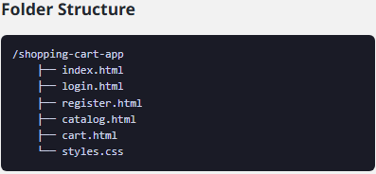
index.html
<!DOCTYPE html>
<html lang="en">
<head>
<meta charset="UTF-8">
<meta name="viewport" content="width=device-width, initial-scale=1.0">
<link rel="stylesheet" href="styles.css">
<title>Shopping Cart App</title>
</head>
<body>
<header>
<div class="logo">
<imgsrc="logo.png" alt="Logo" />
</div>
<h1>Welcome to Our Shopping Cart</h1>
<nav>
<a href="login.html">Login</a>
<a href="register.html">Register</a>
<a href="catalog.html">Catalog</a>
<a href="cart.html">Cart</a>
</nav>
</header>
<main>
<h2>Your one-stop shopping solution!</h2>
<p>Explore our catalog and start shopping today.</p>
</main>
<footer>
<p>&copy; 2025 Shopping Cart App</p>
<p>Follow us on
<a href="#">Facebook</a>
<a href="#">Twitter</a>
<a href="#">Instagram</a>
</p>
</footer>
</body>
</html>
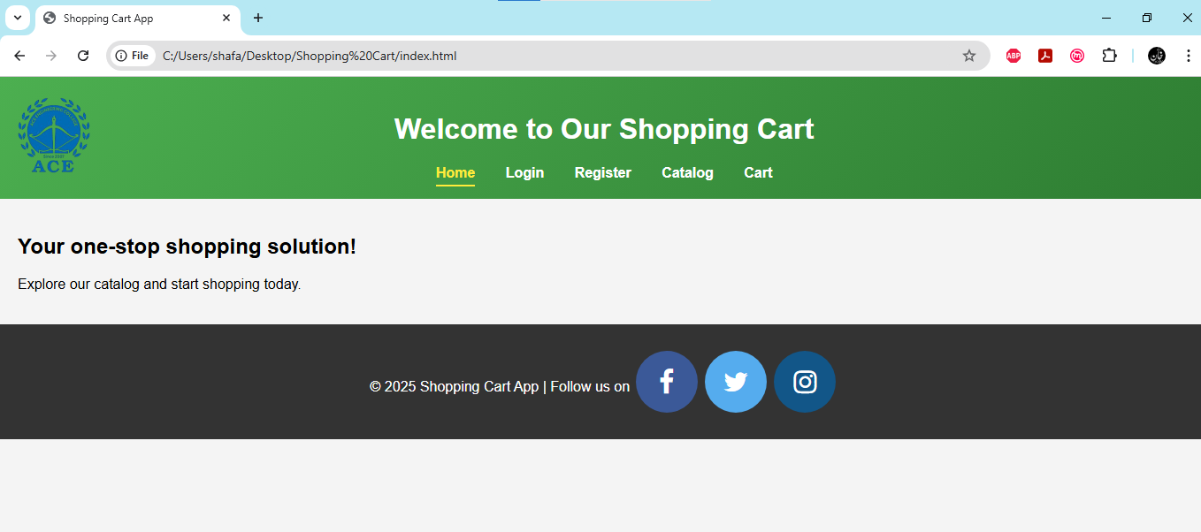

login.html
<!DOCTYPE html>
<html lang="en">
<head>
<meta charset="UTF-8">
<meta name="viewport" content="width=device-width, initial-scale=1.0">
<link rel="stylesheet" href="https://cdnjs.cloudflare.com/ajax/libs/font-awesome/4.7.0/css/font-awesome.min.css">
<link rel="stylesheet" href="styles.css">
<title>Shopping Cart App</title>
</head>
<body>
<header>
<div class="logo">
<imgsrc="logo.png" alt="Logo" />
</div>
<h1>Welcome to Our Shopping Cart</h1>
<nav>
<a href="index.html">Home</a>
<a href="login.html" class="active">Login</a>
<a href="register.html">Register</a>
<a href="catalog.html">Catalog</a>
<a href="cart.html">Cart</a>
</nav>
</header>
<main>
<form class="form-container">
<input type="text" placeholder="Username" required>
<input type="password" placeholder="Password" required>
<button type="submit"class="gradient-button">Login</button>
<p>Don't have an account? <a href="register.html">Register here</a></p>
</form>
</main>
<footer>
<p>&copy; 2025 Shopping Cart App | Follow us on
<a href="#" class="fa fa-facebook"></a>
<a href="#" class="fa fa-twitter"></a>
<a href="#" class="fa fa-instagram"></a>
</p>
</footer>
</body>
</html>
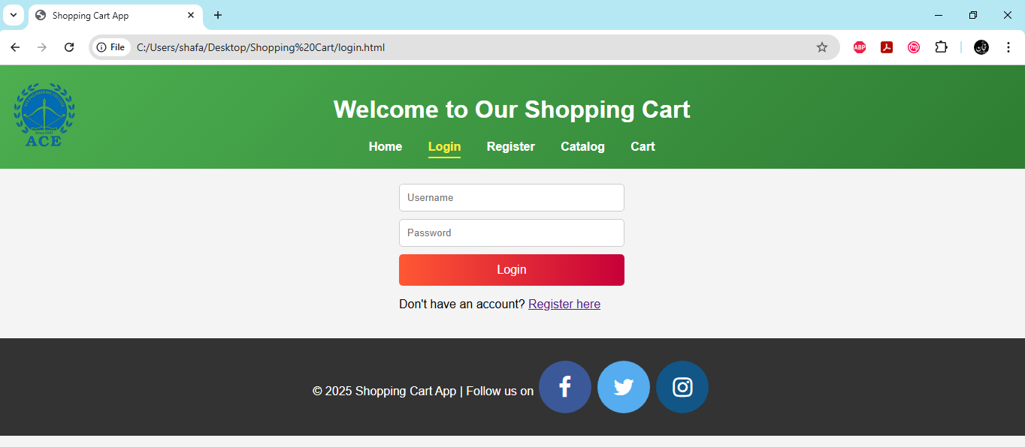

register.html
<!DOCTYPE html>
<html lang="en">
<head>
<meta charset="UTF-8">
<meta name="viewport" content="width=device-width, initial-scale=1.0">
<link rel="stylesheet" href="https://cdnjs.cloudflare.com/ajax/libs/font-awesome/4.7.0/css/font-awesome.min.css">
<link rel="stylesheet" href="styles.css">
<title>Shopping Cart App</title>
</head>
<body>
<header>
<div class="logo">
<imgsrc="logo.png" alt="Logo" />
</div>
<h1>Welcome to Our Shopping Cart</h1>
<nav>
<a href="index.html">Home</a>
<a href="login.html">Login</a>
<a href="register.html" class="active">Register</a>
<a href="catalog.html">Catalog</a>
<a href="cart.html">Cart</a>
</nav>
</header>
<main>
<form class="form-container">
<input type="text" placeholder="Username" required>
<input type="email" placeholder="Email" required>
<input type="password" placeholder="Password" required>
<button type="submit" class="gradient-button">Register</button>
<p>Already have an account? <a href="login.html">Login here</a></p>
</form>
</main>
<footer>
<p>&copy; 2025 Shopping Cart App |
Follow us on
<a href="#" class="fa fa-facebook"></a>
<a href="#" class="fa fa-twitter"></a>
<a href="#" class="fa fa-instagram"></a>
</p>
</footer>
</body>
</html>
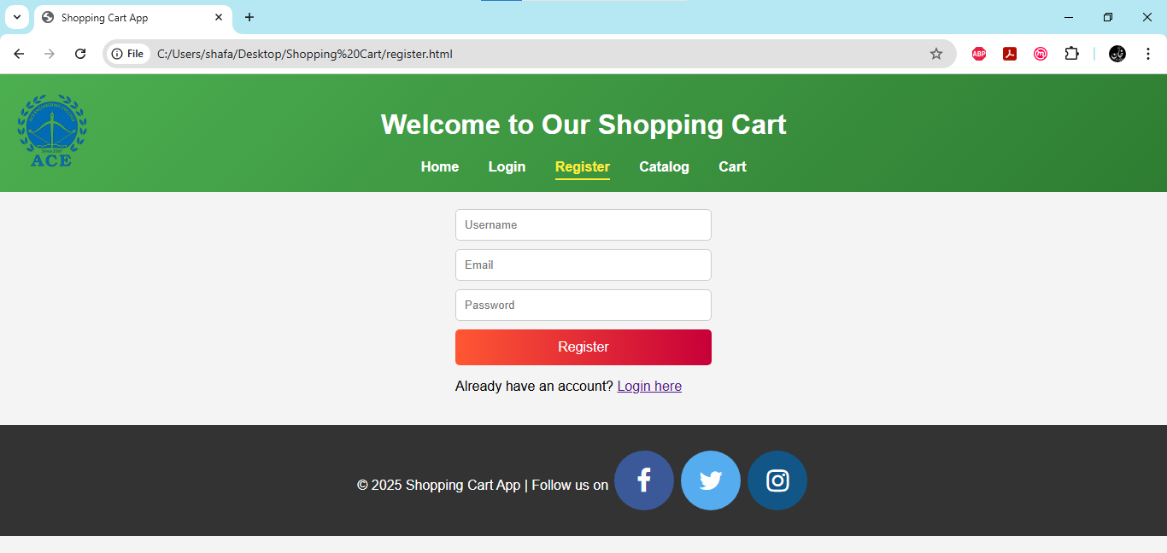
catalog.html
<!DOCTYPE html>
<html lang="en">
<head>
<meta charset="UTF-8">
<meta name="viewport" content="width=device-width, initial-scale=1.0">
<link rel="stylesheet" href="https://cdnjs.cloudflare.com/ajax/libs/font-awesome/4.7.0/css/font-awesome.min.css">
<link rel="stylesheet" href="styles.css">
<title>Shopping Cart App</title>
</head>
<body>
<header>
<div class="logo">
<imgsrc="logo.png" alt="Logo" />
</div>
<h1>Welcome to Our Shopping Cart</h1>
<nav>
<a href="index.html">Home</a>
<a href="login.html">Login</a>
<a href="register.html">Register</a>
<a href="catalog.html" class="active">Catalog</a>
<a href="cart.html">Cart</a>
</nav>
</header>
<main class="grid-container">
<div class="product">
<h2>Product 1</h2>
<p>Description of Product 1</p>
<button class="gradient-button">Add to Cart</button>
</div>
<div class="product">
<h2>Product 2</h2>
<p>Description of Product 2</p>
<button class="gradient-button">Add to Cart</button>
</div>
<div class="product">
<h2>Product 3</h2>
<p>Description of Product 3</p>
<button class="gradient-button">Add to Cart</button>
</div>
</main>
<footer>
<p>&copy; 2025 Shopping Cart App | Follow us on
<a href="#" class="fa fa-facebook"></a><a href="#" class="fa fa-twitter"></a>
<a href="#" class="fa fa-instagram"></a>
</p>
</footer>
</body>
</html>
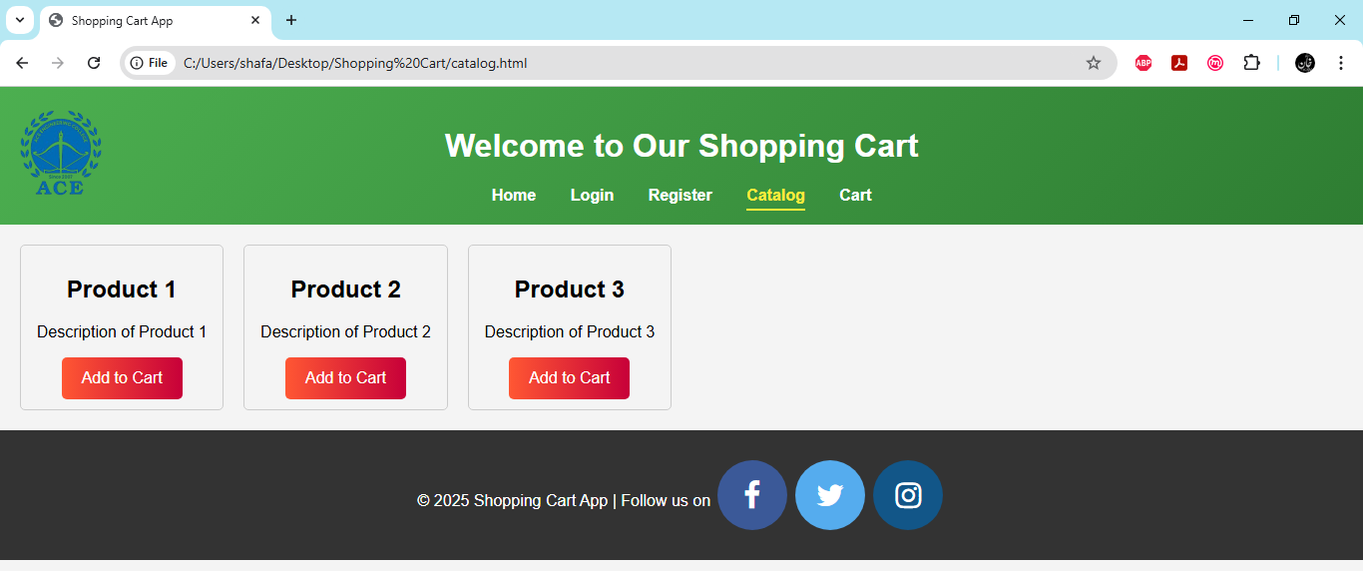
cart.html
<!DOCTYPE html>
<html lang="en">
<head>
<meta charset="UTF-8">
<meta name="viewport" content="width=device-width, initial-scale=1.0">
<link rel="stylesheet" href="https://cdnjs.cloudflare.com/ajax/libs/font-awesome/4.7.0/css/font-awesome.min.css">
<link rel="stylesheet" href="styles.css">
<title>Shopping Cart App</title>
</head>
<body>
<header>
<div class="logo">
<imgsrc="logo.png" alt="Logo" />
</div>
<h1>Welcome to Our Shopping Cart</h1>
<nav>
<a href="index.html">Home</a>
<a href="login.html">Login</a>
<a href="register.html">Register</a>
<a href="catalog.html">Catalog</a>
<a href="cart.html" class="active">Cart</a>
</nav>
</header>
<main>
<div class="cart-item">
<h2>Product 1</h2>
<p>Quantity: 1</p>
<button class="gradient-button">Remove</button>
</div>
<div class="cart-item">
<h2>Product 2</h2>
<p>Quantity: 2</p>
<button class="gradient-button">Remove</button>
</div>
<button class="checkout">Checkout</button>
</main>
<footer>
<p>&copy; 2025 Shopping Cart App | Follow us on
<a href="#" class="fa fa-facebook"></a>
<a href="#" class="fa fa-twitter"></a>
<a href="#" class="fa fa-instagram"></a>
</p>
</footer>
</body>
</html>
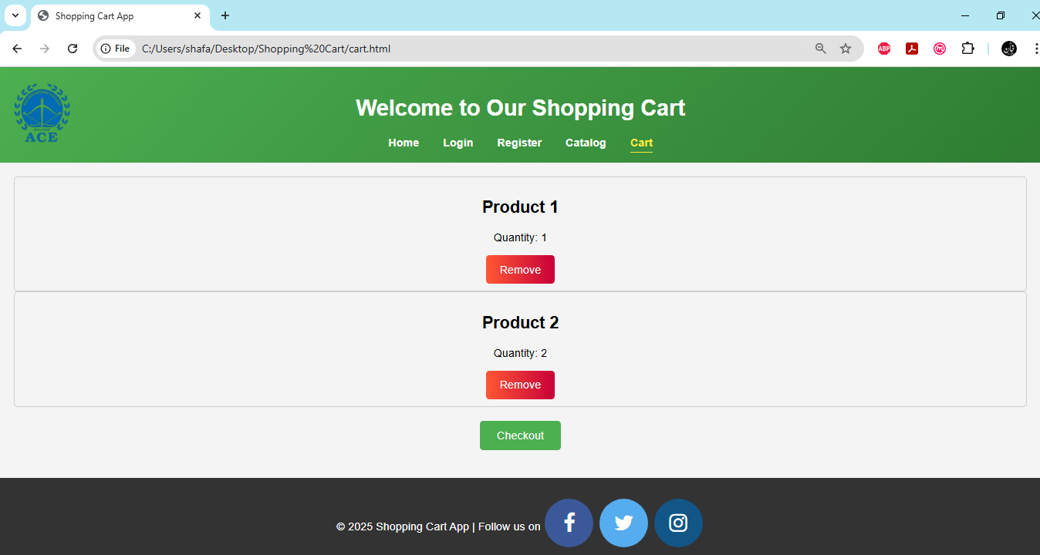

styles.css
* {
box-sizing: border-box;
}
body {
font-family: Arial, sans-serif;
margin: 0;
padding: 0;
background-color: #f4f4f4;
}
header {
background: linear-gradient(135deg, #4CAF50 0%, #2E7D32 100%);
color: white;
padding: 20px 10px;
text-align: center;
position: relative;
}
.logoimg {
max-width: 90px; /* Adjust size as needed */
height: 90px;
position: absolute;
left: 20px;
top: 20px;
}
nav {
margin-top: 20px;
}
nav a {
margin: 0 15px;
color: white;
text-decoration: none;
font-weight: bold;
transition: color 0.3s;
}
nav a:hover {
color: #ffeb3b; /* Highlight color on hover */
}
/* Style for the active link */
nav .active {
color: #ffeb3b; /* Highlight color for the active link */
font-weight: bold;
border-bottom: 2px solid #ffeb3b; /* Underline effect */
padding-bottom: 5px; /* Space for underline */
}
main {
padding: 20px;
}
.form-container {
display: flex;
flex-direction: column;
max-width: 300px;
margin: auto;
}
.form-container input {
margin-bottom: 10px;
padding: 10px;
border: 1px solid #ccc;
border-radius: 5px;
}
.grid-container {
display: grid;
grid-template-columns: repeat(auto-fill, minmax(200px, 1fr));
gap: 20px;
}
.product, .cart-item {
border: 1px solid #ccc;
padding: 10px;
text-align: center;
border-radius: 5px;
transition: transform 0.2s;
}
.product:hover, .cart-item:hover {
transform: scale(.9); /* Slightly enlarge on hover */
box-shadow: 0 4px 8px rgba(0, 0, 0, 0.2);
}
.checkout {
display: block;
margin: 20px auto;
padding: 10px 20px;
background-color: #4CAF50;
color: white;
border: none;
cursor: pointer;
border-radius: 5px;
transition: background-color 0.3s;
}
/* Checkout Button Styles */
.checkout-container {
text-align: center; /* Center the button */
margin-top: 20px; /* Space above the button */
}
.checkout {
padding: 12px 24px; /* Vertical and horizontal padding */
font-size: 16px; /* Font size */
color: white; /* Text color */
background-color: #4CAF50; /* Button background color */
border: none; /* Remove default border */
border-radius: 5px; /* Rounded corners */
cursor: pointer; /* Pointer cursor on hover */
transition: background-color 0.3s, transform 0.2s; /* Smooth transition for background and scale */
}
/* Hover effect */
.checkout:hover {
background-color: #388E3C; /* Darker shade on hover */
transform: scale(1.05); /* Slightly enlarge on hover */
}
/* Active state */
.checkout:active {
transform: scale(0.95); /* Slightly shrink on click */
}
/* Focus state for accessibility */
.checkout:focus {
outline: none; /* Remove default outline */
box-shadow: 0 0 0 2px #ffeb3b; /* Add a custom focus outline */
}
.gradient-button {
padding: 12px 20px; /* Vertical and horizontal padding */
font-size: 16px; /* Font size */
color: white; /* Text color */
background: linear-gradient(90deg, #FF5733, #C70039); /* Gradient background */
border: none; /* Remove default border */
border-radius: 5px; /* Rounded corners */
cursor: pointer; /* Pointer cursor on hover */
transition: background 0.3s, transform 0.2s; /* Smooth transition for background and scale */
}
/* Hover effect */
.gradient-button:hover {
background: linear-gradient(90deg, #C70039, #FF5733); /* Reverse gradient on hover */
transform: scale(1.05); /* Slightly enlarge on hover */
}
/* Active state */
.gradient-button:active {
transform: scale(0.95); /* Slightly shrink on click */
}
/* Focus state for accessibility */
.gradient-button:focus {
outline: none; /* Remove default outline */
box-shadow: 0 0 0 3px rgba(255, 87, 51, 0.5); /* Add a custom focus outline */
}
.fa {
padding: 20px;
font-size: 30px;
width: 70px;
text-align: center;
text-decoration: none;
margin: 5px 2px;
border-radius:100%;
}
.fa:hover {
opacity: 0.7;
}
.fa-facebook {
background: #3B5998;
color: white;
}
.fa-twitter {
background: #55ACEE;
color: white;
}
.fa-instagram {
background: #125688;
color: white;
}
footer {
background-color: #333;
color: white;
text-align: center;
padding: 20px;
position: relative;
bottom: 0;
width: 100%;
}
footer p {
margin: 5px 0;
}
footer a {
color: #ffeb3b; /* Highlight color for links */
text-decoration: none;
transition: color 0.3s;
}
footer a:hover {
color: #fff; /* Change color on hover */
}

Experiment 2: Make the above web application responsive web application using Bootstrap framework.
To make shopping cart web application responsive using the Bootstrap framework, you can leverage Bootstrap's grid system, components, and utility classes. Below provided a basic structure that incorporates Bootstrap to create a responsive layout, including the buttons.
Step 1: Include Bootstrap
First, you need to include Bootstrap in your HTML. You can use a CDN for quick setup. Add this within the <head> section of all HTML files:
html
<!DOCTYPE html>
<html lang="en">
<head>
<meta charset="UTF-8">
<meta name="viewport" content="width=device-width, initial-scale=1.0">
<title>Shopping Cart</title>
<link rel="stylesheet" href="https://stackpath.bootstrapcdn.com/bootstrap/4.5.2/css/bootstrap.min.css">
<link rel="stylesheet" href="styles.css"><!-- Your custom styles -->
</head>
<body>
Step 2: Create a Responsive Layout
Here is the procedure how to structure your shopping cart application using Bootstrap's grid system and components:
HTML Structure
<body>
<div class="container mt-5">
<h1 class="text-center">Shopping Cart</h1>
<div class="row">
<div class="col-md-8">
<div class="card">
<div class="card-header">
<h5>Your Items</h5>
</div>
<div class="card-body">
<!-- Example item -->
<div class="row my-3">
<div class="col-6">
<h6>Product Name</h6>
<p>Price: $10.00</p>
</div>
<div class="col-6 text-right">
<button class="btnbtn-primary flat-button">Add to Cart</button>
</div>
</div>
<!-- Add more products as needed -->
</div>
</div>
</div>
<div class="col-md-4">
<div class="card">
<div class="card-header">
<h5>Checkout</h5>
</div>
<div class="card-body text-center">
<button class="btnbtn-danger gradient-button">Checkout Now</button>
</div>
</div>
</div>
</div>
</div>

<script src="https://code.jquery.com/jquery-3.5.1.slim.min.js"></script>
<script src="https://cdn.jsdelivr.net/npm/@popperjs/core@2.9.2/dist/umd/popper.min.js"></script>
<script src="https://stackpath.bootstrapcdn.com/bootstrap/4.5.2/js/bootstrap.min.js"></script>
</body>
Step 3: Update CSS Styles
You can keep the previous CSS styles for your buttons in a separate styles.css file. Here’s how you might update it to ensure compatibility with Bootstrap:
styles.css
/* Flat Button Styles */
.flat-button {
padding: 12px 20px; /* Vertical and horizontal padding */
font-size: 16px; /* Font size */
color: white; /* Text color */
background-color: #007BFF; /* Button background color */
border: none; /* Remove default border */
border-radius: 5px; /* Rounded corners */
cursor: pointer; /* Pointer cursor on hover */
transition: background-color 0.3s, transform 0.2s; /* Smooth transition for background and scale */
}
/* Hover effect */
.flat-button:hover {
background-color: #0056b3; /* Darker shade on hover */
transform: scale(1.05); /* Slightly enlarge on hover */
}
/* Active state */
.flat-button:active {
transform: scale(0.95); /* Slightly shrink on click */
}
/* Focus state for accessibility */
.flat-button:focus {
outline: none; /* Remove default outline */
box-shadow: 0 0 0 3px rgba(0, 123, 255, 0.5); /* Add a custom focus outline */
}
/* Gradient Button Styles */
.gradient-button {
padding: 12px 20px; /* Vertical and horizontal padding */
font-size: 16px; /* Font size */
color: white; /* Text color */
background: linear-gradient(90deg, #FF5733, #C70039); /* Gradient background */
border: none; /* Remove default border */
border-radius: 5px; /* Rounded corners */
cursor: pointer; /* Pointer cursor on hover */
transition: background 0.3s, transform 0.2s; /* Smooth transition for background and scale */
}
/* Hover effect */
.gradient-button:hover {
background: linear-gradient(90deg, #C70039, #FF5733); /* Reverse gradient on hover */
transform: scale(1.05); /* Slightly enlarge on hover */
}
/* Active state */
.gradient-button:active {
transform: scale(0.95); /* Slightly shrink on click */
}
/* Focus state for accessibility */
.gradient-button:focus {
outline: none; /* Remove default outline */
box-shadow: 0 0 0 3px rgba(255, 87, 51, 0.5); /* Add a custom focus outline */
}
Explanation of the Structure
1. Bootstrap Grid System: The layout uses a responsive grid. The .container class centers the content, while .row and .col-md-* classes create a responsive grid layout that adjusts based on the screen size.
2. Cards: Bootstrap's card component is used to display product items and the checkout section, providing a clean and organized look.
3. Buttons: The buttons are styled with custom classes (flat-button and gradient-button) tomaintain the unique styles we created earlier.
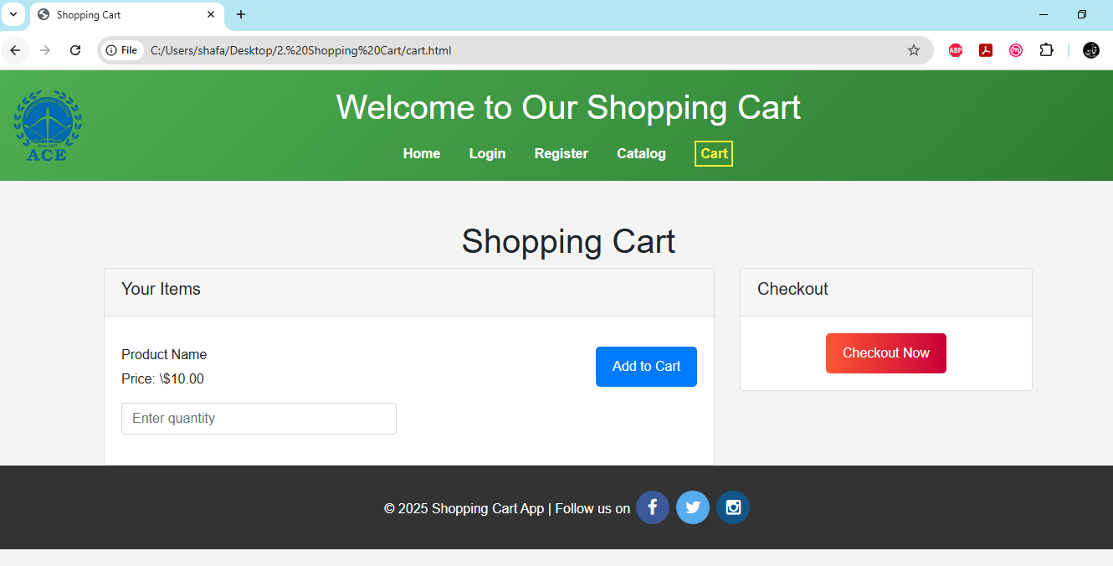
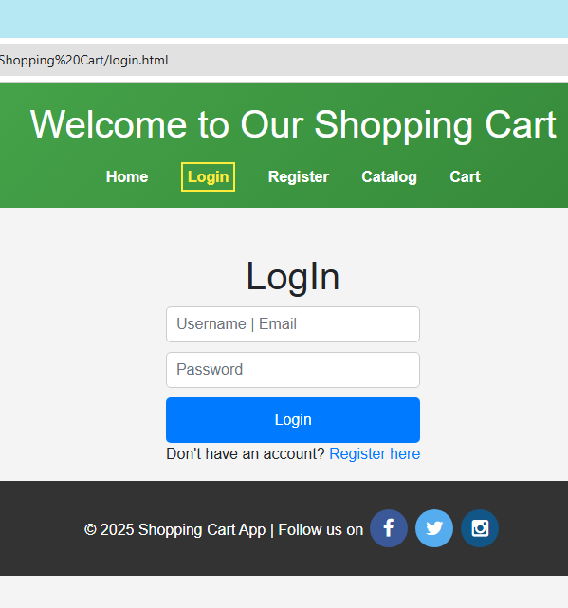

Experiment 3: Use JavaScript for doing client – side validation of the pages implemented in experiment 1 and experiment 2.
To implement client-side validation for your shopping cart web application, you can use JavaScript to ensure that users provide valid input before they can proceed with actions like adding items to the cart or checking out. Below, I'll demonstrate how to add simple client-side validation for a hypothetical form where users can specify the quantity of items they wish to purchase.
Step 1: Update HTML Structure
Let’s add a form for the user to specify the quantity of items they want to purchase. We'll include input validation for this field.
Updated HTML Structure
<body>
<div class="container mt-5">
<h1 class="text-center">Shopping Cart</h1>
<div class="row">
<div class="col-md-8">
<div class="card">
<div class="card-header">
<h5>Your Items</h5>
</div>
<div class="card-body">
<!-- Example item -->
<div class="row my-3">
<div class="col-6">
<h6>Product Name</h6>
<p>Price: $10.00</p>
<input type="number" id="quantity" class="form-control" placeholder="Enter quantity" min="1" required>
</div>
<div class="col-6 text-right">
<button class="btnbtn-primary flat-button" id="addToCart">Add to Cart</button>
</div>
</div>
<!-- Add more products as needed -->
</div>
</div>
</div>
<div class="col-md-4">
<div class="card">
<div class="card-header">
<h5>Checkout</h5>
</div>
<div class="card-body text-center">
<button class="btn btn-danger gradient-button" id="checkout">Checkout Now</button>
</div>
</div>
</div>
</div>
</div>
<script src="https://code.jquery.com/jquery-3.5.1.slim.min.js"></script>
<script src="https://cdn.jsdelivr.net/npm/@popperjs/core@2.9.2/dist/umd/popper.min.js"></script>
<script src="https://stackpath.bootstrapcdn.com/bootstrap/4.5.2/js/bootstrap.min.js"></script>
<script src="script.js"></script><!-- Your custom JavaScript -->
</body>
Step 2: Create JavaScript for Validation
Now, create a `script.js` file to handle the client-side validation. This script will validate the quantity input when the user clicks the "Add to Cart" or "Checkout Now" button.
script.js
document.addEventListener('DOMContentLoaded', function () {
const addToCartButton = document.getElementById('addToCart');
const checkoutButton = document.getElementById('checkout');
const quantityInput = document.getElementById('quantity');

// Function to validate quantity
function validateQuantity() {
const quantity = parseInt(quantityInput.value);
if (isNaN(quantity) || quantity < 1) {
alert("Please enter a valid quantity (greater than 0).");
quantityInput.focus();
return false;
}
return true;
}
// Event listener for Add to Cart button
addToCartButton.addEventListener('click', function () {
if (validateQuantity()) {
alert("Item added to cart successfully!");
// Here you can add code to actually add the item to the cart
}
});
// Event listener for Checkout button
checkoutButton.addEventListener('click', function () {
if (validateQuantity()) {
alert("Proceeding to checkout...");
// Here you can add code to handle the checkout process
}
});
});
Explanation of the JavaScript Code
1. Event Listener for DOMContentLoaded: Ensures that the script runs after the DOM is fully loaded.
2. Get Elements: The script retrieves the buttons and the quantity input field using getElementById.
3. Validation Function: The validateQuantity function checks if the quantity is a valid number and greater than 0. If not, it alerts the user and focuses on the input field.
4. Add to Cart Button: When clicked, it checks the quantity validation. If valid, it alerts the user that the item has been added to the cart (you can replace this with actual cart handling logic).
5. Checkout Button: Similar to the "Add to Cart" button, it validates the quantity before proceeding to checkout (you can replace this with actual checkout logic).

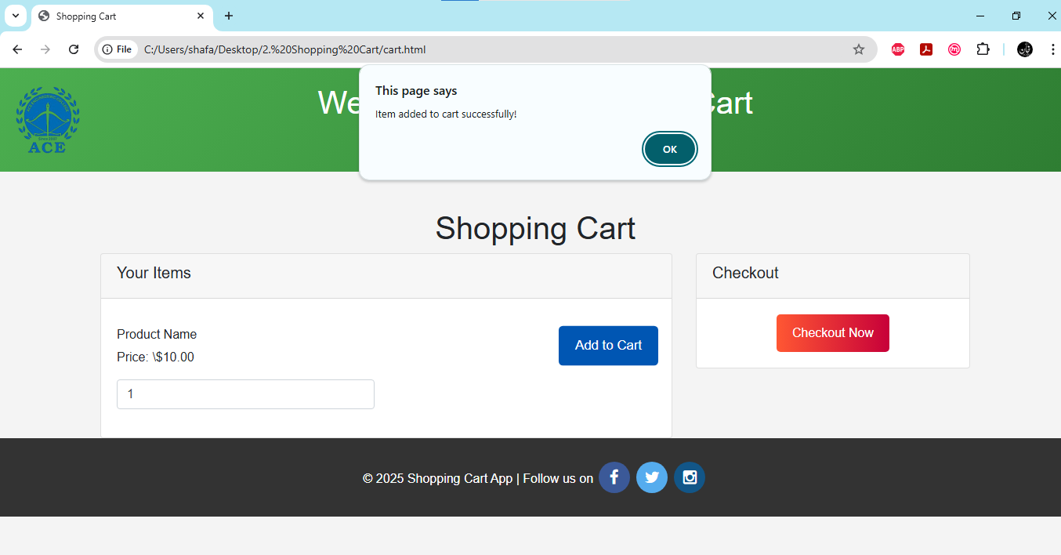

Experiment 4:Explore the features of ES6 like arrow functions, callbacks, promises, async/await. Implementan application for reading the weather information from openweathermap.org and display theinformation in the form of a graph on the web page.

To create an application that fetches weather information from OpenWeatherMap and displays it in the form of a graph, utilizing several ES6 features such as arrow functions, callbacks, promises, and async/await. Also use a charting library like Chart.js to visualize the data. Follow the steps provided below to accomplish this experiment.
Step 1: Set Up Your HTML Structure
index.html
<!DOCTYPE html>
<html lang="en">
<head>
<meta charset="UTF-8">
<meta name="viewport" content="width=device-width, initial-scale=1.0">
<link rel="stylesheet" href="https://stackpath.bootstrapcdn.com/bootstrap/4.5.2/css/bootstrap.min.css">
<title>Weather App</title>
<link rel="stylesheet" href="https://stackpath.bootstrapcdn.com/bootstrap/4.5.2/css/bootstrap.min.css">
<script src="https://cdn.jsdelivr.net/npm/chart.js"></script>
</head>
<body>
<div class="container mt-5">
<h1 class="text-center">Weather Information</h1>
<div class="form-group">
<label for="city">Enter City Name:</label>
<input type="text" id="cityInput" class="form-control" placeholder="City Name">
<button onclick="getWeather()" class="btnbtn-primary mt-3">Get Weather</button>
</div>
<div>
<h2>Weather Results:</h2>
<pre style="font-size:16pt; border: 2px solid aqua;
border-radius: 5px; padding:5px;font-family:cambria"id="weatherResult"></pre>
</div>
</div>
<script src="script.js"></script>
</body>
</html>
Step 2: Create the JavaScript File
script.js
// Replace with your OpenWeatherMap API key
const apiKey = "f6dc4f4e7b873301bc6afaeb13e4ea58";
async function getWeather() {
const city = document.getElementById("cityInput").value;
const weatherResult = document.getElementById("weatherResult");
if (!city) {
weatherResult.textContent = "Please enter a city name.";
return;
}
try {
const response = await fetch(
`https://api.openweathermap.org/data/2.5/weather?q=${city}&appid=${apiKey}`
);
const data = await response.json();
if (data.cod === 200) {
const weather = data.weather[0].description;
const temperature = (data.main.temp - 273.15).toFixed(2); // Convert Kelvin to Celsius
weatherResult.textContent = `Weather: ${weather}\nTemperature: ${temperature}°C`;
} else {
weatherResult.textContent = `Error: ${data.message}`;
}
} catch (error) {
weatherResult.textContent = `Error fetching weather data: ${error.message}`;
}
}

Step 3: Run the Application
1. Make sure to replace YOUR_API_KEY in the JavaScript file with a valid OpenWeatherMap API key.
2. Open the index.html file in a web browser.
3. Enter a city name and click the "Get Weather" button to see the current temperature displayed on the graph.
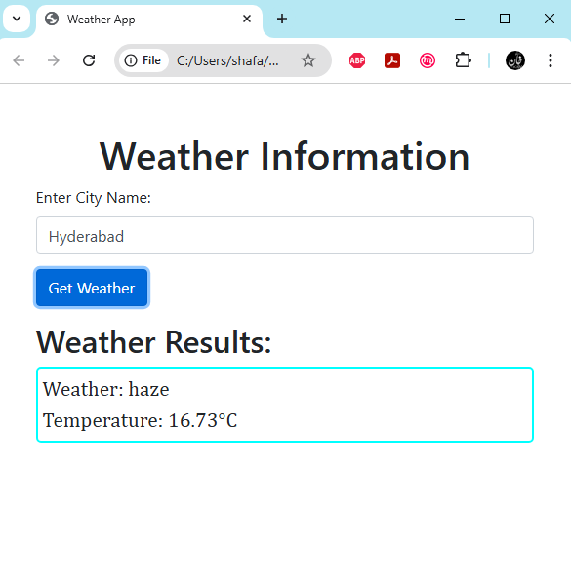

Experiment 5: Develop a java standalone application that connects with the database (Oracle / mySql) and perform the CRUD operation on the database tables.
To develop a standalone Java application that connects to a MySQL database and performs CRUD (Create, Read, Update, Delete) operations for a shopping cart application, need to follow several steps. Follow the steps provided below:
Step 1: Set Up Your Environment
1. Install MySQL: Make sure you have MySQL Server installed on your machine.
2. Create a Database: Create a new database for the shopping cart application.
3. Add MySQL Connector: Download the MySQL JDBC driver (Connector/J) and add it to your project's classpath.
4. javac -classpath /path/to/your/libs/* /path/to/your/JavaFile.java
5. Use Above Command and attach your jar file to your classpath
6. javac -classpath ".;mysql-connector-j-9.2.0.jar" Main.java
7. java -classpath ".;mysql-connector-j-9.2.0.jar" Main
Step 2: Create the Database and Table
You can create a database and a table for the shopping cart using the following SQL commands.
Database creation
CREATE DATABASE shopping_cart;
Open Database
USE shopping_cart;
Create Products Table
CREATE TABLE products (
id INT AUTO_INCREMENT PRIMARY KEY,
name VARCHAR(255) NOT NULL,
price DECIMAL(10, 2) NOT NULL,
quantity INT NOT NULL
);
Step 3: Create the Java Application
1. Create a Java Project: Create a new Java project in your IDE (like IntelliJ IDEA or Eclipse).
2. Add MySQL Connector: Ensure that the MySQL JDBC driver is added to your project's libraries.

Step 4: Implement the CRUD Operations
Main.java
import java.sql.*;
import java.util.Scanner;
public class Main {
private static final String URL = "jdbc:mysql://localhost:3306/shopping_cart";
private static final String USER = "root"; // Your MySQL username
private static final String PASSWORD = "password"; // Your MySQL password
public static void main(String[] args) {
try (Connection connection = DriverManager.getConnection(URL, USER, PASSWORD)) {
Scanner scanner = new Scanner(System.in);
int choice;
do {
System.out.println("1. Add Product");
System.out.println("2. View Products");
System.out.println("3. Update Product");
System.out.println("4. Delete Product");
System.out.println("5. Exit");
System.out.print("Enter your choice: ");
choice = scanner.nextInt();
scanner.nextLine(); // Consume newline
switch (choice) {
case 1:
addProduct(connection, scanner);
break;
case 2:
viewProducts(connection);
break;
case 3:
updateProduct(connection, scanner);
break;
case 4:
deleteProduct(connection, scanner);
break;
case 5:
System.out.println("Exiting...");
break;
default:
System.out.println("Invalid choice. Please try again.");
}
} while (choice != 5);
} catch (SQLException e) {
e.printStackTrace();
}
}
private static void addProduct(Connection connection, Scanner scanner) throws SQLException {
System.out.print("Enter product name: ");
String name = scanner.nextLine();
System.out.print("Enter product price: ");
double price = scanner.nextDouble();
System.out.print("Enter product quantity: ");
int quantity = scanner.nextInt();
String sql = "INSERT INTO products (name, price, quantity) VALUES (?, ?, ?)";
try (PreparedStatement statement = connection.prepareStatement(sql)) {
statement.setString(1, name);
statement.setDouble(2, price);
statement.setInt(3, quantity);
statement.executeUpdate();
System.out.println("Product added successfully.");
}
}
private static void viewProducts(Connection connection) throws SQLException {
String sql = "SELECT * FROM products";
try (Statement statement = connection.createStatement();
ResultSetresultSet = statement.executeQuery(sql)) {
System.out.println("Products in the Shopping Cart:");
while (resultSet.next()) {
System.out.println("ID: " + resultSet.getInt("id") +
", Name: " + resultSet.getString("name") +
", Price: " + resultSet.getDouble("price") +
", Quantity: " + resultSet.getInt("quantity"));
}
}
}
private static void updateProduct(Connection connection, Scanner scanner) throws SQLException {
System.out.print("Enter product ID to update: ");
int id = scanner.nextInt();
scanner.nextLine(); // Consume newline
System.out.print("Enter new product name: ");
String name = scanner.nextLine();
System.out.print("Enter new product price: ");
double price = scanner.nextDouble();
System.out.print("Enter new product quantity: ");
int quantity = scanner.nextInt();
String sql = "UPDATE products SET name = ?, price = ?, quantity = ? WHERE id = ?";
try (PreparedStatement statement = connection.prepareStatement(sql)) {
statement.setString(1, name);
statement.setDouble(2, price);
statement.setInt(3, quantity);
statement.setInt(4, id);
int rowsUpdated = statement.executeUpdate();
if (rowsUpdated> 0) {
System.out.println("Product updated successfully.");
} else {
System.out.println("Product not found.");
}
}
}
private static void deleteProduct(Connection connection, Scanner scanner) throws SQLException {
System.out.print("Enter product ID to delete: ");
int id = scanner.nextInt();
String sql = "DELETE FROM products WHERE id = ?";
try (PreparedStatement statement = connection.prepareStatement(sql)) {
statement.setInt(1, id);
int rowsDeleted = statement.executeUpdate();
if (rowsDeleted> 0) {
System.out.println("Product deleted successfully.");
} else {
System.out.println("Product not found.");
}
}
}
}

Step 5:Running the Application
1. Compile and Run: Compile and run the Main.java file in your IDE or command line.
2. Perform CRUD Operations: Follow the prompts to add, view, update, or delete products in the shopping cart.

Output
Enter The choice from below options
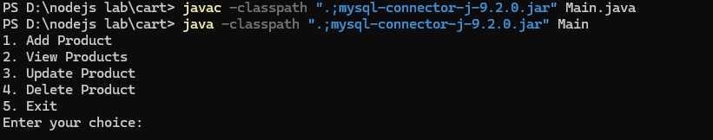
Selected Option 2 to view products
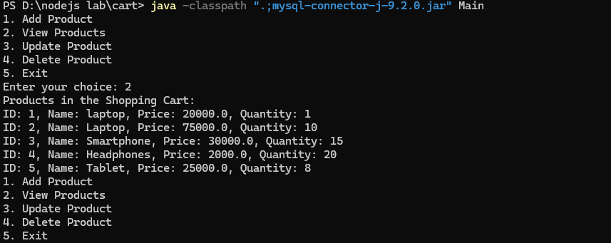

Experiment 6:Create an xml for the bookstore. Validate the same using both DTD and XSD.
To validate XML against XSD using java. Follow the provided steps below to complete this experiment.
Step 1: Create Your XML, DTD, and XSD Files
Create three files in your project directory: bookstore.xml, bookstore.dtd, and bookstore.xsd.
bookstore.xml
<?xml version="1.0" encoding="UTF-8"?>
<!DOCTYPE bookstore SYSTEM "bookstore.dtd">
<bookstore xmlns:xsi="http://www.w3.org/2001/XMLSchema-instance"
xsi:noNamespaceSchemaLocation="bookstore.xsd">
<book>
<title>The Great Gatsby</title>
<author>F. Scott Fitzgerald</author>
<price>10.99</price>
<genre>Fiction</genre>
<publish_date>1925-04-10</publish_date>
</book>
<book>
<title>1984</title>
<author>George Orwell</author>
<price>9.99</price>
<genre>Dystopian</genre>
<publish_date>1949-06-08</publish_date>
</book>
<book>
<title>To Kill a Mockingbird</title>
<author>Harper Lee</author>
<price>7.99</price>
<genre>Fiction</genre>
<publish_date>1960-07-11</publish_date>
</book>
</bookstore>
bookstore.dtd
<!ELEMENT bookstore (book+)>
<!ELEMENT book (title, author, price, genre, publish_date)>
<!ELEMENT title (#PCDATA)>
<!ELEMENT author (#PCDATA)>
<!ELEMENT price (#PCDATA)>
<!ELEMENT genre (#PCDATA)>
<!ELEMENT publish_date (#PCDATA)>
bookstore.xsd
<?xml version="1.0" encoding="UTF-8"?>
<xs:schemaxmlns:xs="http://www.w3.org/2001/XMLSchema">

<xs:element name="bookstore">
<xs:complexType>
<xs:sequence>
<xs:element name="book" maxOccurs="unbounded">
<xs:complexType>
<xs:sequence>
<xs:element name="title" type="xs:string"/>
<xs:element name="author" type="xs:string"/>
<xs:element name="price" type="xs:decimal"/>
<xs:element name="genre" type="xs:string"/>
<xs:element name="publish_date" type="xs:date"/>
</xs:sequence>
</xs:complexType>
</xs:element>
</xs:sequence>
</xs:complexType>
</xs:element>
</xs:schema>

Step 2: Create Java file to validate XML against XSD and DTD
import org.w3c.dom.Document;
import org.xml.sax.SAXException;
import javax.xml.XMLConstants;
import javax.xml.parsers.DocumentBuilder;
import javax.xml.parsers.DocumentBuilderFactory;
import javax.xml.validation.Schema;
import javax.xml.validation.SchemaFactory;
import javax.xml.validation.Validator;
import javax.xml.parsers.ParserConfigurationException;
import javax.xml.transform.stream.StreamSource;
import java.io.File;
import java.io.IOException;
public class ValidateXML {
//Validating XML XSD Method
public static void validateXSD(){
try {
// Validate against XSD
SchemaFactoryschemaFactory = SchemaFactory.newInstance(XMLConstants.W3C_XML_SCHEMA_NS_URI);
Schema schema = schemaFactory.newSchema(new File("bookstore.xsd"));
Validator validator = schema.newValidator();
validator.validate(new StreamSource(new File("bookstore.xml")));
System.out.println("XML is valid against XSD.");
} catch (SAXException e) {
System.err.println("XML is NOT valid against XSD: " + e.getMessage());
} catch (IOException e) {
System.err.println("Error reading XML or XSD file: " + e.getMessage());
}
}
//Validating XML DTD Method
public static void validateDTD(){
try {
// Load the XML file
File xmlFile = new File("bookstore.xml");
File dtdFile = new File("bookstore.dtd");
// Create a DocumentBuilderFactory
DocumentBuilderFactory factory = DocumentBuilderFactory.newInstance();
factory.setValidating(true); // Enable validation
factory.setNamespaceAware(true);
factory.setAttribute("http://java.sun.com/xml/jaxp/properties/schemaLanguage", "http://www.w3.org/2001/XMLSchema"); // Set schema language
// Create a DocumentBuilder
DocumentBuilder builder = factory.newDocumentBuilder();

// Parse the XML file
Document document = builder.parse(xmlFile);
// Validate against DTD
System.out.println("XML is valid against DTD.");
} catch (ParserConfigurationException e) {
System.err.println("Parser configuration error: " + e.getMessage());
} catch (SAXException e) {
System.err.println("XML is NOT valid: " + e.getMessage());
} catch (IOException e) {
System.err.println("I/O error: " + e.getMessage());
}
}
public static void main(String[] args) {
System.out.println("VALIDATING XML XSD......");
validateXSD();
System.out.println("------------------------");
System.out.println("VALIDATING XML DTD......");
validateDTD();
}
}
Step 3: Compile and run ValidateXML.java file to view the results
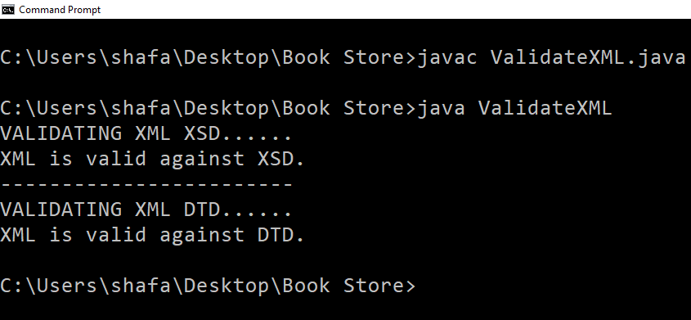

7. Design a Controller with Servlet That Provides the Interaction with Application Developed in Experiment 1 and the Database Created in Experiment 5.

To develop a Servlet Controller that interacts with the Shopping Cart Application and the Products Database.
Step 1: Set Up Your Environment:
Required Software
- JDK 8+
- Apache Tomcat (10.x or 9.x)
- MySQL Server
- MySQL Connector JAR
Step 2: Steps to run
Set Up Eclipse and Apache Tomcat
- Open Eclipse
- Install Tomcat Plugin (If Not Installed)
  - Go to Help → Eclipse Marketplace
  - Search for "Apache Tomcat"
  - Install the Eclipse Web Tools Platform (WTP) if needed.
- Add Tomcat Server
  - Go to Window → Show View → Servers
  - Right-click and select New → Server
  - Choose Apache → Tomcat 9.0 (or your installed version)
  - Click Next, set Tomcat installation directory, and finish.

Step 3: Create a New Dynamic Web Project
- Go to File → New → Dynamic Web Project
- Enter Project Name: ViewProductsServlet
- Select Target Runtime: Choose Apache Tomcat 9.0
- Click Next → Next → Finish

Step 4: Add MySQL JDBC Driver
- Download MySQL Connector JAR → Download
- Copy the JAR to WebContent/WEB-INF/lib/
- Right-click the project → Build Path → Configure Build Path → Add External JARs
- Select mysql-connector-java.jar and click Apply
Create the Servlet
- Right-click on src → New → Servlet
- Enter Class Name: ViewProductsServlet
- Click Finish
- Modify ViewProductsServlet.java as follows
Step 5: Code Implementation
ViewProductsServlet.java
import java.io.*;
import java.util.*;
import jakarta.servlet.*;
import jakarta.servlet.http.*;
import java.sql.*;

public class ViewProductsServlet extends HttpServlet {
private static final String DB_URL = "jdbc:mysql://localhost:3306/shopping_cart";
private static final String DB_USERNAME = "root";
private static final String DB_PASSWORD = "root";

protected void doGet(HttpServletRequest request, HttpServletResponse response) throws ServletException, IOException {
response.setContentType("text/html");
PrintWriter out = response.getWriter();

HttpSession session = request.getSession(); // Get the session
List<String> transactionHistory = (List<String>) session.getAttribute("transactionHistory");

if (transactionHistory == null) {
transactionHistory = new ArrayList<>();
}

Connection conn = null;
Statement stmt = null;
ResultSet rs = null;

try {
Class.forName("com.mysql.cj.jdbc.Driver");
conn = DriverManager.getConnection(DB_URL, DB_USERNAME, DB_PASSWORD);
stmt = conn.createStatement();
String sql = "SELECT * FROM products;";
rs = stmt.executeQuery(sql);

out.println("<html><head><title>Shopping Cart</title></head><body>");
out.println("<!DOCTYPE html>\r\n"
+ "<html lang=\"en\">\r\n"
+ "<head>\r\n"
+ "<meta charset=\"UTF-8\">\r\n"
+ "<meta name=\"viewport\" content=\"width=device-width, initial-scale=1.0\">\r\n"
+ "<link rel=\"stylesheet\" href=\"https://cdnjs.cloudflare.com/ajax/libs/font-awesome/4.7.0/css/font-awesome.min.css\">\r\n"
+ "<title>Shopping Cart App</title>\r\n"
+ "<style>\r\n"
+ "* {\r\n"
+ " box-sizing: border-box;\r\n"
+ "}\r\n"
+ "body {\r\n"
+ " font-family: Arial, sans-serif;\r\n"
+ " margin: 0;\r\n"
+ " padding: 0;\r\n"
+ " background-color: #f4f4f4;\r\n"
+ "}\r\n"
+ "header {\r\n"
+ " background: linear-gradient(135deg, #4CAF50 0%, #2E7D32 100%);\r\n"
+ " color: white;\r\n"
+ " padding: 20px 10px;\r\n"
+ " text-align: center;\r\n"
+ " position: relative;\r\n"
+ "}\r\n"

+ ".logo img {\r\n"
+ " max-width: 90px;\r\n"
+ " height: 90px;\r\n"
+ " position: absolute;\r\n"
+ " left: 20px;\r\n"
+ " top: 20px;\r\n"
+ "}\r\n"
+ "nav {\r\n"
+ " margin-top: 20px;\r\n"
+ "}\r\n"
+ "nav a {\r\n"
+ " margin: 0 15px;\r\n"
+ " color: white;\r\n"
+ " text-decoration: none;\r\n"
+ " font-weight: bold;\r\n"
+ " transition: color 0.3s;\r\n"
+ "}\r\n"
+ "nav a:hover {\r\n"
+ " color: #ffeb3b;\r\n"
+ "}\r\n"
+ "nav .active {\r\n"
+ " color: #ffeb3b;\r\n"
+ " font-weight: bold;\r\n"
+ " border-bottom: 2px solid #ffeb3b;\r\n"
+ " padding-bottom: 5px;\r\n"
+ "}\r\n"
+ "main {\r\n"
+ " padding: 20px;\r\n"
+ "}\r\n"
+ ".cart-item {\r\n"
+ " border: 1px solid #ccc;\r\n"
+ " padding: 10px;\r\n"
+ " text-align: center;\r\n"
+ " border-radius: 5px;\r\n"
+ " transition: transform 0.2s;\r\n"
+ " margin-bottom: 10px;\r\n"
+ "}\r\n"
+ ".cart-item:hover {\r\n"
+ " transform: scale(.9);\r\n"
+ " box-shadow: 0 4px 8px rgba(0, 0, 0, 0.2);\r\n"
+ "}\r\n"
+ ".checkout {\r\n"
+ " display: block;\r\n"
+ " margin: 20px auto;\r\n"
+ " padding: 12px 24px;\r\n"
+ " font-size: 16px;\r\n"
+ " color: white;\r\n"
+ " background-color: #4CAF50;\r\n"
+ " border: none;\r\n"
+ " border-radius: 5px;\r\n"
+ " cursor: pointer;\r\n"
+ " transition: background-color 0.3s, transform 0.2s;\r\n"
+ "}\r\n"
+ ".checkout:hover {\r\n"
+ " background-color: #388E3C;\r\n"
+ " transform: scale(1.05);\r\n"
+ "}\r\n"
+ ".checkout:active {\r\n"
+ " transform: scale(0.95);\r\n"
+ "}\r\n"
+ ".checkout:focus {\r\n"
+ " outline: none;\r\n"
+ " box-shadow: 0 0 0 2px #ffeb3b;\r\n"
+ "}\r\n"
+ ".gradient-button {\r\n"
+ " padding: 12px 20px;\r\n"
+ " font-size: 16px;\r\n"
+ " color: white;\r\n"
+ " background: linear-gradient(90deg, #FF5733, #C70039);\r\n"
+ " border: none;\r\n"
+ " border-radius: 5px;\r\n"
+ " cursor: pointer;\r\n"
+ " transition: background 0.3s, transform 0.2s;\r\n"
+ "}\r\n"
+ ".gradient-button:hover {\r\n"
+ " background: linear-gradient(90deg, #C70039, #FF5733);\r\n"
+ " transform: scale(1.05);\r\n"
+ "}\r\n"
+ ".gradient-button:active {\r\n"
+ " transform: scale(0.95);\r\n"
+ "}\r\n"
+ ".gradient-button:focus {\r\n"
+ " outline: none;\r\n"
+ " box-shadow: 0 0 0 3px rgba(255, 87, 51, 0.5);\r\n"
+ "}\r\n"
+ ".fa {\r\n"
+ " padding: 20px;\r\n"
+ " font-size: 30px;\r\n"
+ " width: 70px;\r\n"
+ " text-align: center;\r\n"
+ " text-decoration: none;\r\n"
+ " margin: 5px 2px;\r\n"
+ " border-radius:100%;\r\n"
+ "}\r\n"
+ ".fa:hover {\r\n"
+ " opacity: 0.7;\r\n"
+ "}\r\n"
+ ".fa-facebook {\r\n"
+ " background: #3B5998;\r\n"
+ " color: white;\r\n"
+ "}\r\n"
+ ".fa-twitter {\r\n"
+ " background: #55ACEE;\r\n"
+ " color: white;\r\n"
+ "}\r\n"
+ ".fa-instagram {\r\n"
+ " background: #125688;\r\n"
+ " color: white;\r\n"
+ "}\r\n"
+ "footer {\r\n"
+ " background-color: #333;\r\n"
+ " color: white;\r\n"
+ " text-align: center;\r\n"
+ " padding: 20px;\r\n"
+ " position: relative;\r\n"
+ " bottom: 0;\r\n"
+ " width: 100%;\r\n"
+ "}\r\n"
+ "footer p {\r\n"
+ " margin: 5px 0;\r\n"
+ "}\r\n"
+ "footer a {\r\n"
+ " color: #ffeb3b;\r\n"
+ " text-decoration: none;\r\n"
+ " transition: color 0.3s;\r\n"
+ "}\r\n"
+ "footer a:hover {\r\n"
+ " color: #fff;\r\n"
+ "}\r\n"
+ "</style>\r\n"
+ "</head>\r\n"
+ "<body>\r\n"
+ "<header>\r\n"
+ " <div class=\"logo\">\r\n"
+ " <img src=\"logo.png\" alt=\"Logo\" />\r\n"
+ " </div>\r\n"
+ " <h1>Welcome to Our Shopping Cart</h1>\r\n"
+ " <nav>\r\n"
+ " <a href=\"index.html\">Home</a>\r\n"
+ " <a href=\"login.html\">Login</a>\r\n"
+ " <a href=\"register.html\">Register</a>\r\n"
+ " <a href=\"catalog.html\">Catalog</a>\r\n"
+ " <a href=\"cart.html\" class=\"active\">Cart</a>\r\n"
+ " </nav>\r\n"
+ "</header>\r\n"
+ "");
out.println("<h2 style='text-align:center;'>Available Products</h2>");
out.println("<center>");
out.println("<table border='1';align-items: center;><tr><th>ID</th><th>Name</th><th>Price</th><th>Action</th></tr>");

while (rs.next()) {
int id = rs.getInt("id");
String name = rs.getString("name");
String price = rs.getString("price");

out.println("<tr>");
out.println("<td>" + id + "</td>");
out.println("<td>" + name + "</td>");
out.println("<td>" + price + "</td>");
out.println("<td><a href='TransactionServlet?id=" + id + "&name=" + name + "&price=" + price + "'>Buy Now</a></td>");
out.println("</tr>");
}

out.println("</table>");
out.println("<br>");
out.println("<br>");
out.println("<a href='TransactionServlet'>View Transaction History</a>");
out.println("</body></html>");
out.println("</center>");
out.println("\r\n"
+ "<footer>\r\n"
+ " <p>&copy; 2025 Shopping Cart App | Follow us on \r\n"
+ " <a href=\"#\" class=\"fa fa-facebook\"></a>\r\n"
+ " <a href=\"#\" class=\"fa fa-twitter\"></a>\r\n"
+ " <a href=\"#\" class=\"fa fa-instagram\"></a>\r\n"
+ " </p>\r\n"
+ "</footer>\r\n"
+ "</body>\r\n"
+ "</html>");
} catch (Exception e) {
e.printStackTrace();
out.println("<p>Error: " + e.getMessage() + "</p>");
} finally {
try { if (rs != null) rs.close(); if (stmt != null) stmt.close(); if (conn != null) conn.close(); }
catch (SQLException e) { e.printStackTrace(); }
}
}
}

Step 6: Creating of web.xml (deployment descriptor) file to configure servlets
web.xml
<web-app xmlns="http://java.sun.com/xml/ns/javaee" xmlns:xsi="http://www.w3.org/2001/XMLSchema-instance" xsi:schemaLocation="http://java.sun.com/xml/ns/javaee http://java.sun.com/xml/ns/javaee/web-app_3_0.xsd" version="3.0">
<servlet>
<servlet-name>ViewProductsServlet</servlet-name>
<servlet-class>ViewProductsServlet</servlet-class>
</servlet>
<servlet-mapping>
<servlet-name>ViewProductsServlet</servlet-name>
<url-pattern>/fetchData</url-pattern>
</servlet-mapping>
</web-app>
Output:
Products data that is stored in SQL Table
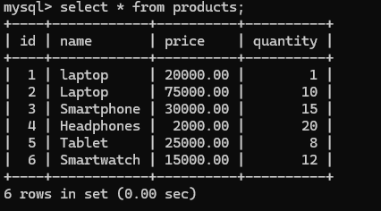

Controller Servlet Suceessfully fetches the Products from the SQL database table.

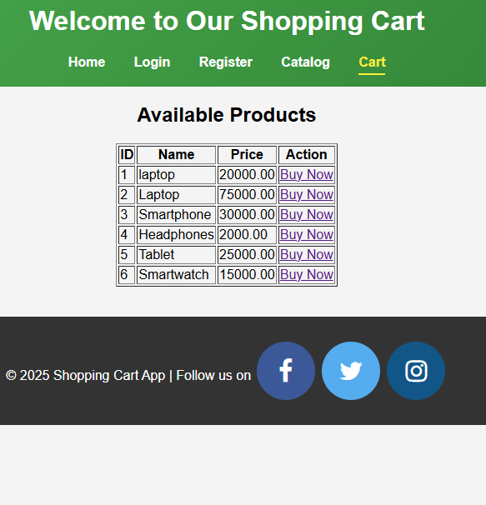

Experiment 8. Maintaining the Transactional History of Any User Using Session Tracking Mechanisms (Cookies, HTTP Session)
AIM: To explore session tracking mechanisms (Cookies, HTTP Session) for maintaining transactional history.
DESCRIPTION: This experiment demonstrates how to use HTTP Sessions and Cookies to track a user’s activity and store transactional history.
Source Code
- Cookies: Cookies are small data pieces stored on a user's device by a web browser, used to maintain user-specific information between the client and the server.
Step 1: Continuing Experiment 7 create a Java file to maintain cookies and sessions related to transactions performed.
TransactionServlet.java
import jakarta.servlet.*;
import jakarta.servlet.http.*;
import java.io.*;
import java.util.*;

public class TransactionServlet extends HttpServlet {
private static final String TRANSACTION_HISTORY_ATTRIBUTE = "transactionHistory";
@Override
protected void doGet(HttpServletRequest request, HttpServletResponse response) throws ServletException, IOException {
response.setContentType("text/html");
PrintWriter out = response.getWriter();
// Get or create session
HttpSession session = request.getSession(true);
List<String> transactionHistory = (List<String>) session.getAttribute(TRANSACTION_HISTORY_ATTRIBUTE);
// Initialize transaction history if it doesn't exist
if (transactionHistory == null) {
transactionHistory = new ArrayList<>();
session.setAttribute(TRANSACTION_HISTORY_ATTRIBUTE, transactionHistory);
}
// Get item details from request parameters
String itemName = request.getParameter("name");
String itemId = request.getParameter("id");

// Validate and add transaction
if (itemName != null && !itemName.trim().isEmpty() && itemId != null && !itemId.trim().isEmpty()) {
String newTransaction = "Purchased Item: " + itemName + " (ID: " + itemId + ")";
transactionHistory.add(newTransaction);
}
// Display transaction history
out.println("<html><body>");
out.println("<h2>User Transaction History</h2>");
out.println("<p>Current Session ID: " + session.getId() + "</p>");

out.println("<h3>Your Transaction History:</h3>");
if (transactionHistory.isEmpty()) {
out.println("<p>No transactions made yet.</p>");
} else {
out.println("<ul>");
for (String transaction : transactionHistory) {
out.println("<li>" + transaction + "</li>");
}
out.println("</ul>");
}
// Navigation links
out.println("<a href='/ViewProductsServlet/fetchData'>View Available Products</a><br>");
out.println("<a href='/TransactionServlet'>Add Another Transaction</a>");
out.println("</body></html>");
}
}

ViewProductsServlet.java
import jakarta.servlet.*;
import jakarta.servlet.http.*;
import java.io.*;
import java.util.*;
public class TransactionServlet extends HttpServlet {
private static final String TRANSACTION_HISTORY_ATTRIBUTE = "transactionHistory";
@Override
protected void doGet(HttpServletRequest request, HttpServletResponse response) throws ServletException, IOException {
response.setContentType("text/html");
PrintWriter out = response.getWriter();
// Get or create session
HttpSession session = request.getSession(true);
List<String> transactionHistory = (List<String>) session.getAttribute(TRANSACTION_HISTORY_ATTRIBUTE);
// Initialize transaction history if it doesn't exist
if (transactionHistory == null) {
transactionHistory = new ArrayList<>();
session.setAttribute(TRANSACTION_HISTORY_ATTRIBUTE, transactionHistory);
}
// Get item details from request parameters
String itemName = request.getParameter("name");
String itemId = request.getParameter("id");
// Validate and add transaction
if (itemName != null && !itemName.trim().isEmpty() && itemId != null && !itemId.trim().isEmpty()) {
String newTransaction = "Purchased Item: " + itemName + " (ID: " + itemId + ")";
transactionHistory.add(newTransaction);
}
// Display transaction history
out.println("<html><body>");
out.println("<h2>User Transaction History</h2>");
out.println("<p>Current Session ID: " + session.getId() + "</p>");
out.println("<h3>Your Transaction History:</h3>");
if (transactionHistory.isEmpty()) {
out.println("<p>No transactions made yet.</p>");
} else {
out.println("<ul>");
for (String transaction : transactionHistory) {
out.println("<li>" + transaction + "</li>");
}
out.println("</ul>");
}
// Navigation links
out.println("<a href='/ViewProductsServlet/fetchData'>View Available Products</a><br>");
out.println("<a href='/TransactionServlet'>Add Another Transaction</a>");
out.println("</body></html>");
}
}
web.xml
<web-app xmlns="http://java.sun.com/xml/ns/javaee" xmlns:xsi="http://www.w3.org/2001/XMLSchema-instance" xsi:schemaLocation="http://java.sun.com/xml/ns/javaee http://java.sun.com/xml/ns/javaee/web-app_3_0.xsd" version="3.0">
<servlet>
<servlet-name>ViewProductsServlet</servlet-name>
<servlet-class>ViewProductsServlet</servlet-class>
</servlet>
<servlet-mapping>
<servlet-name>ViewProductsServlet</servlet-name>
<url-pattern>/fetchData</url-pattern>
</servlet-mapping>
<servlet>
<servlet-name>TransactionServlet</servlet-name>
<servlet-class>TransactionServlet</servlet-class>
</servlet>
<servlet-mapping>
<servlet-name>TransactionServlet</servlet-name>
<url-pattern>/TransactionServlet</url-pattern>
</servlet-mapping>
</web-app>

Output:
No Transactions are made by the user in the cart page
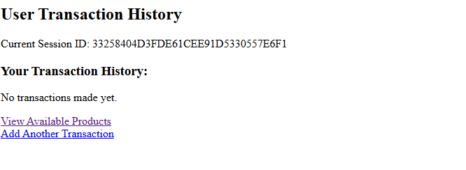

When the user clicks on the cart page, transactions will get saved in the session.
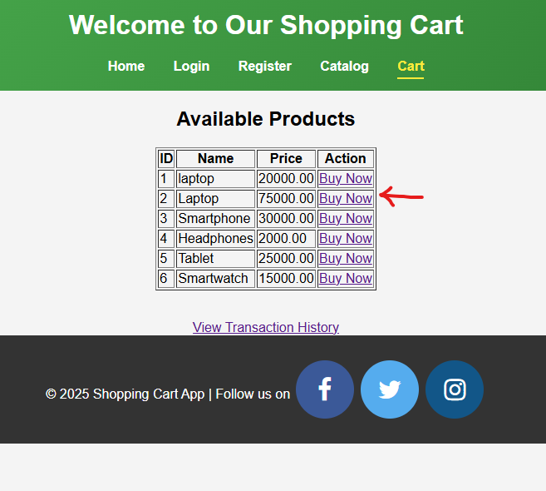
In case if the user buys the products, the Session gets saved in the Transactional History
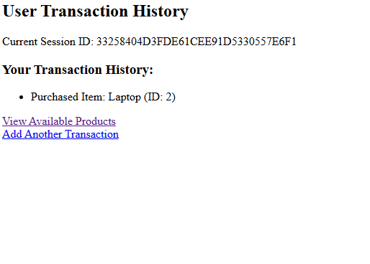

Experiment 9: Create a custom server using http module and explore the other modules of Node JS like OS,path, event.
To create a custom server using http module and exploring the core modules of NodeJs we need to write the following code and run as instructed respectively.
server.js
const http = require("http");
const os = require("os");
const path = require("path");
const EventEmitter = require("events");

// Create a custom event emitter
const eventEmitter = new EventEmitter();
// Create an HTTP server
const server = http.createServer((req, res) => {
if (req.url === "/") {
res.writeHead(200, { "Content-Type": "text/plain" });
res.end("Welcome to the Node.js Server!");
} else if (req.url === "/os") {
res.writeHead(200, { "Content-Type": "text/plain" });
res.end(`OS Info: ${os.type()} ${os.release()}`);
} else if (req.url === "/path") {
const filePath = path.join(__dirname, "server.js");
res.writeHead(200, { "Content-Type": "text/plain" });
res.end(`File Path: ${filePath}`);
} else if (req.url === "/event") {
eventEmitter.on("greet", () => {
res.writeHead(200, { "Content-Type": "text/plain" });
res.end("Event Emitted: Hello World!");
});
eventEmitter.emit("greet");
} else {
res.writeHead(404, { "Content-Type": "text/plain" });
res.end("404 Not Found");
}
});
// Start the server
const PORT = 3000;
server.listen(PORT, () => {
console.log(`Server is running on http://localhost:${PORT}`);
});
How to Run:
Run the server using the command:
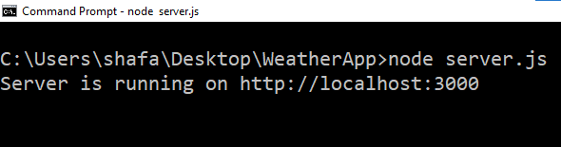
Open your browser and visit:
http://localhost:3000for the welcome message.
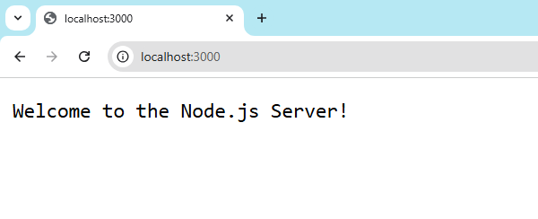
http://localhost:3000/osfor OS information and http://localhost:3000/pathfor the file path.
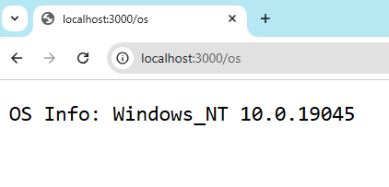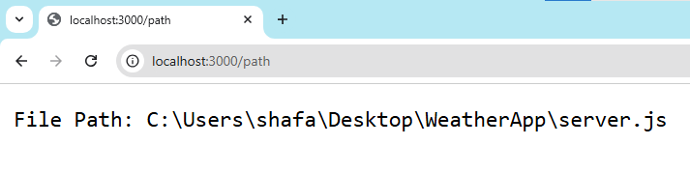

http://localhost:3000/eventto trigger an event.
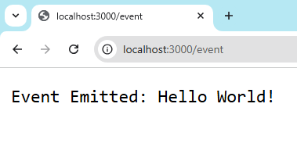
http://localhost:3000/component -- component is not a nodejs module
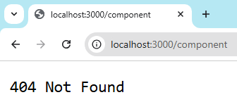

Experiment 10: Develop an express web application that can interact with REST API to perform CRUD operations on student data. (Use Postman)
To perform the CRUD operations on student data using nodejs and need to perform the following steps:
Step 1: Create nodejs Application (studentapp)
npx create-node-app studentapp
cd studentapp
Step 2: Create app.js and index.html file as follows:
App.js
const express = require("express");
const cors = require("cors"); // Import the CORS middleware
const app = express();

// Enable CORS for all routes
app.use(cors());

// Middleware to parse JSON request bodies
app.use(express.json());

let students = [
{ id: 1, name: "John Doe", age: 20 },
{ id: 2, name: "Jane Smith", age: 22 },
];

// GET all students
app.get("/students", (req, res) => {
res.json(students);
});

// GET a single student by ID
app.get("/students/:id", (req, res) => {
const student = students.find((s) => s.id === parseInt(req.params.id));
if (!student) return res.status(404).json({ message: "Student not found" });
res.json(student);
});

// POST a new student
app.post("/students", (req, res) => {
const student = {
id: students.length + 1,
name: req.body.name,
age: req.body.age,
};
students.push(student);
res.status(201).json(student);
});

// PUT (update) a student by ID
app.put("/students/:id", (req, res) => {
const student = students.find((s) => s.id === parseInt(req.params.id));
if (!student) return res.status(404).json({ message: "Student not found" });

student.name = req.body.name;
student.age = req.body.age;
res.json(student);
});

// DELETE a student by ID
app.delete("/students/:id", (req, res) => {
const studentIndex = students.findIndex((s) => s.id === parseInt(req.params.id));
if (studentIndex === -1) return res.status(404).json({ message: "Student not found" });

students.splice(studentIndex, 1);
res.status(204).send();
});

// Start the server
const PORT = 3000;
app.listen(PORT, () => {
console.log(`Server is running on http://localhost:${PORT}`);
});

Index.html
<!DOCTYPE html>
<html lang="en">
<head>
<meta charset="UTF-8">
<meta name="viewport" content="width=device-width, initial-scale=1.0">
<title>CRUD OPERATIONs - Student Data</title>
</head>
<body>
<h1>CRUD OPERATIONs | Student Data</h1>
<button onclick="getStudents()">GET All Students</button>
<button onclick="createStudent()">POST New Student</button>
<button onclick="updateStudent(1)">PUT Update Student</button>
<button onclick="deleteStudent(1)">DELETE Student</button>

<h2>Response:</h2>
<pre id="response"></pre>

<script>
const responseElement = document.getElementById("response");

// Function to handle API responses
async function handleResponse(response) {
if (!response.ok) {
throw new Error(`HTTP error! Status: ${response.status}`);
}
return response.json();
}

// GET all students
async function getStudents() {
try {
const response = await fetch("http://localhost:3000/students");
const data = await handleResponse(response);
responseElement.textContent = JSON.stringify(data, null, 2);
} catch (error) {
responseElement.textContent = `Error: ${error.message}`;
}
}

// POST a new student
async function createStudent() {
try {
const response = await fetch("http://localhost:3000/students", {
method: "POST",
headers: { "Content-Type": "application/json" },
body: JSON.stringify({ name: "Alice Johnson", age: 21 }),
});
const data = await handleResponse(response);
responseElement.textContent = JSON.stringify(data, null, 2);
} catch (error) {
responseElement.textContent = `Error: ${error.message}`;
}
}

// PUT (update) a student by ID
async function updateStudent(id) {
try {
const response = await fetch(`http://localhost:3000/students/${id}`, {
method: "PUT",
headers: { "Content-Type": "application/json" },
body: JSON.stringify({ name: "John Doe Updated", age: 25 }),
});
const data = await handleResponse(response);
responseElement.textContent = JSON.stringify(data, null, 2);
} catch (error) {
responseElement.textContent = `Error: ${error.message}`;
}
}

// DELETE a student by ID
async function deleteStudent(id) {
try {
const response = await fetch(`http://localhost:3000/students/${id}`, {
method: "DELETE",
});
responseElement.textContent = `Status: ${response.status}`;
} catch (error) {
responseElement.textContent = `Error: ${error.message}`;
}
}
</script>
</body>
</html>
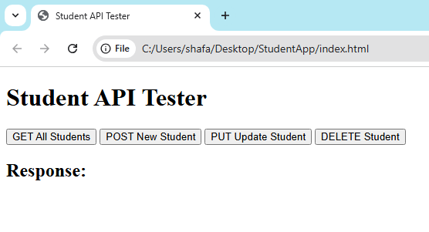
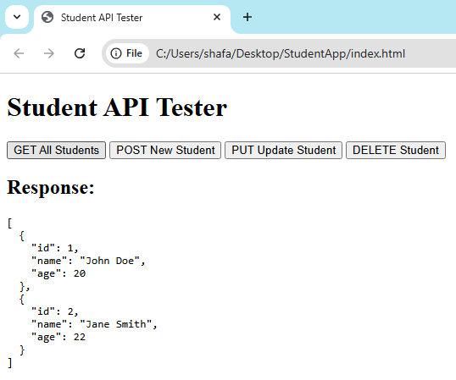
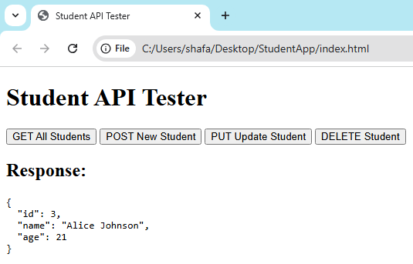

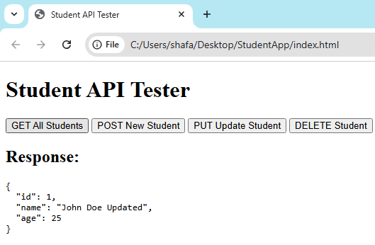
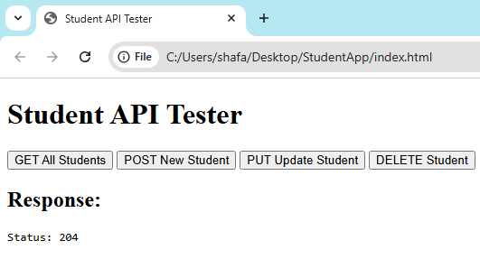

Experiment 11: For the above application create authorized end points using JWT (JSON Web Token).
Project Structure:
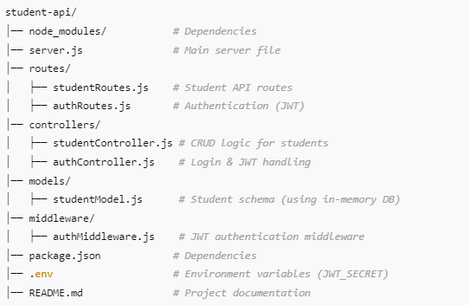
Step 1: Create ExpressJS Application (std-crud-app)
- npx express-generate new std-crud-app
- cd std-crud-app
- npx install (To install dependencies)
- npm install express dotenv jsonwebtoken body-parser cors (To install .env, jsonwebtoken, body-parser and cors along with express)
- npx start (To check the project is build successfully or not)

Step 2: Create server.js this file initializes the server and routes.
server.js
require("dotenv").config();
const express = require("express");
const bodyParser = require("body-parser");
const cors = require("cors");

const studentRoutes = require("./routes/studentRoutes");
const authRoutes = require("./routes/authRoutes");

const app = express();

// Middleware
app.use(bodyParser.json());
app.use(cors());

// Routes
app.use("/api/students", studentRoutes);
app.use("/api/auth", authRoutes);

// Start server
const PORT = process.env.PORT || 5000;
app.listen(PORT, () => console.log(`Server running on port ${PORT}`));

Step 3: Create studentRoute.js in routes directory to create student CRUD API
routes/studentRoute.js
const express = require("express");
const { getAllStudents, getStudentById, createStudent, updateStudent, deleteStudent } = require("../controllers/studentController");
const { authenticateToken } = require("../middleware/authMiddleware");

const router = express.Router();

router.get("/", authenticateToken, getAllStudents);
router.get("/:id", authenticateToken, getStudentById);
router.post("/", authenticateToken, createStudent);
router.put("/:id", authenticateToken, updateStudent);
router.delete("/:id", authenticateToken, deleteStudent);

module.exports = router;

Step 4: Create studentController.js in controllers directory to handle student CRUD operations
controllers/studentController.js
let students = [
{ id: 1, name: "John Doe", age: 20 },
{ id: 2, name: "Jane Doe", age: 22 }
];

exports.getAllStudents = (req, res) => {
res.json(students);
};

exports.getStudentById = (req, res) => {
const student = students.find((s) => s.id == req.params.id);
if (!student) return res.status(404).json({ message: "Student not found" });
res.json(student);
};

exports.createStudent = (req, res) => {
const newStudent = { id: students.length + 1, ...req.body };
students.push(newStudent);
res.status(201).json(newStudent);
};

exports.updateStudent = (req, res) => {
let student = students.find((s) => s.id == req.params.id);
if (!student) return res.status(404).json({ message: "Student not found" });

student = { ...student, ...req.body };
students = students.map((s) => (s.id == req.params.id ? student : s));

res.json(student);
};

exports.deleteStudent = (req, res) => {
students = students.filter((s) => s.id != req.params.id);
res.json({ message: "Student deleted" });
};
Step 5: Create Authentication by creating the authRoute.js and authController.js
route/authRoute.js
const express = require("express");
const { login } = require("../controllers/authController");
const router = express.Router();
router.post("/login", login);
module.exports = router;

controllers/authController.js (It generate JWT Token on successful login)
const jwt = require("jsonwebtoken");
const users = [{ username: "admin", password: "12345" }];
exports.login = (req, res) => {
const { username, password } = req.body;
const user = users.find((u) => u.username === username && u.password === password);
if (!user) return res.status(401).json({ message: "Invalid credentials" });

const token = jwt.sign({ username }, process.env.JWT_SECRET, { expiresIn: "1h" });
res.json({ token });
};

Step 5: Secure the Route using JWT Middleware
middleware/authMiddleware.js (Create a directory middleware and save the js file in it)
const jwt = require("jsonwebtoken");
exports.authenticateToken = (req, res, next) => {
const token = req.header("Authorization");
if (!token) return res.status(403).json({ message: "Access denied" });
try {
const verified = jwt.verify(token.split(" ")[1], process.env.JWT_SECRET);
req.user = verified;
next();
} catch (err) {
res.status(401).json({ message: "Invalid token" });
}
};

Step 6: Configure Environment (Create .env file in root directory and write the following code)
.env
JWT_SECRET=secret_key
PORT=5000
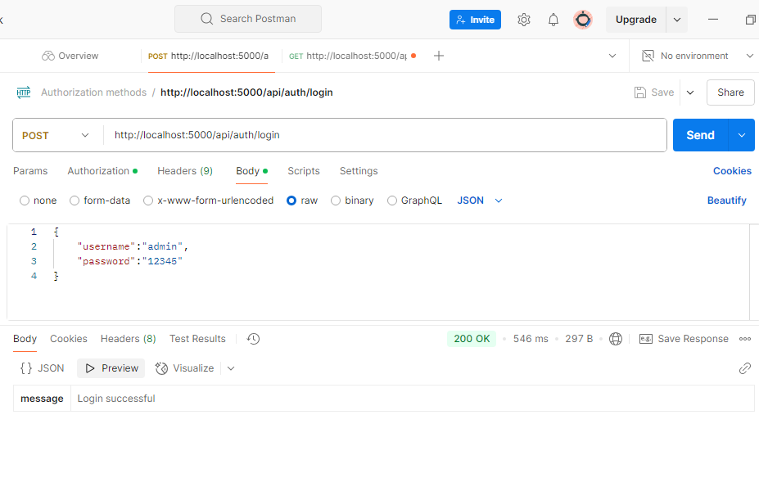

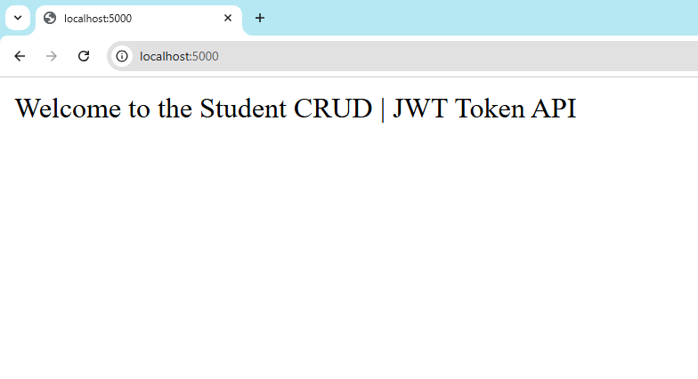
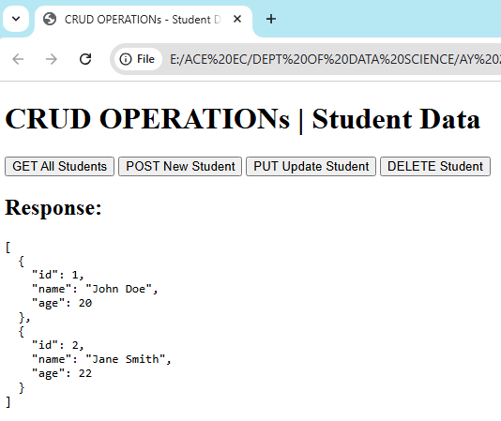
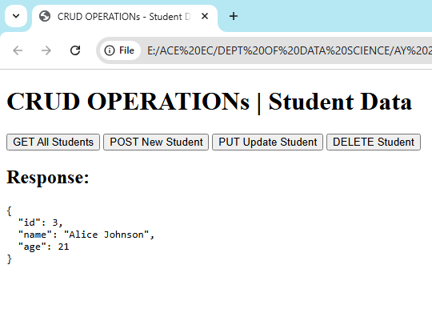

Experiment 12: Create a react application for the student management system having registration, login, contact, about pages and implement routing to navigate through these pages.

Creating a simple React application for a Student Management System with registration, login, contact, and about pages involves several steps. Below is a guide to help you set up the application, including the necessary code snippets.
Step 1: Set Up Your React Application
1. Create a React App:
You can use Create React App to set up your project. Open your terminal and run:
npx create-react-app student-management-system
cd student-management-system
Step 2: Create the Basic Structure
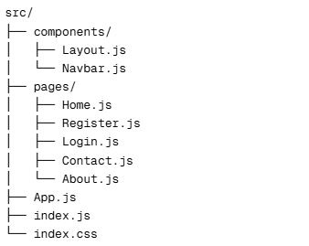
- Create Directories components and pages:
Step 3: Get to the Components directory and create the following files
Navbar.js
import React from 'react';
import { Link } from 'react-router-dom';

const Navbar = () => {
return (

<nav class="navbar navbar-expand-lg navbar-dark bg-dark">
<div class="container-fluid">
<a class="navbar-brand" href="/">STUDENT MS</a>
<button
data-mdb-collapse-init
class="navbar-toggler"
type="button"
data-mdb-target="#navbarNav"
aria-controls="navbarNav"
aria-expanded="false"
aria-label="Toggle navigation"
>
<i class="fas fa-bars"></i>
</button>
<div class="collapse navbar-collapse" id="navbarNav">
<ul class="navbar-nav">
<li class="nav-item">
<a class="nav-link" aria-current="page" href="/">HOME</a>
</li>
<li class="nav-item">
<a class="nav-link" href="/about">ABOUT</a>
</li>
<li class="nav-item">
<a class="nav-link" href="/register">REGISTER</a>
</li>
<li class="nav-item">
<a class="nav-link" href="/contact">CONTACT</a
>
</li>
<li class="nav-item">
<a class="nav-link" href="/login">LOGIN</a
>
</li>
</ul>
</div>
</div>
</nav>
);
};
export default Navbar;
Layout.js
import React from 'react';
import Navbar from './Navbar';

const Layout = ({ children }) => {
return (
<div>

<Navbar />

<div className="container">
{children}
</div>
<footer class="bg-body-tertiary text-center text-lg-start">
<div class="text-center p-3" style={{backgroundColor:"grey"}}>
© 2025 Student Management System. All rights reserved.
<a class="text-body" href="https://www.aceec.ac.in">ACE Engineering College</a>
</div>
</footer>
</div>
);
};

export default Layout;

Step 4: Goto the pages directory and create the following files
Home.js
import React from 'react';

const Home = () => {
return (
<div className="text-center">
<h1 className="text-4xl font-bold mb-4">Welcome to Student Management System</h1>
<p className="text-xl">Manage your students efficiently with our easy-to-use system.</p>
</div>
);
};
export default Home;

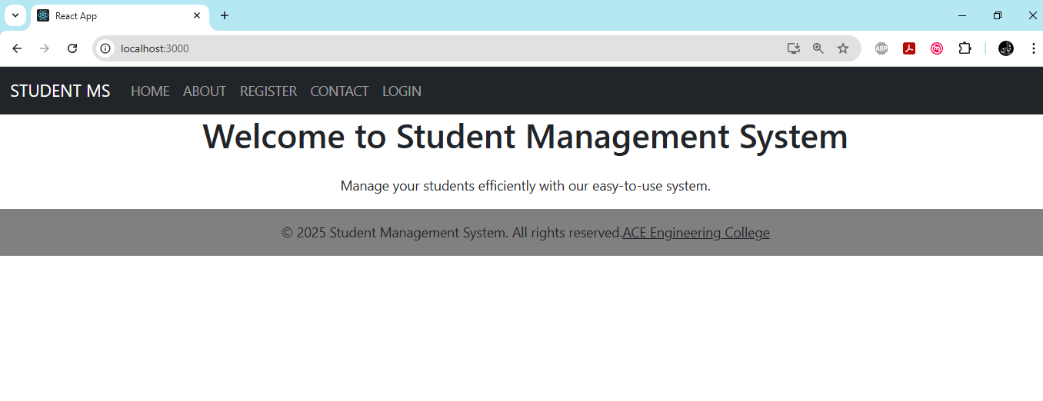
About.js
import React from 'react';
const About = () => {
return (
<div className="max-w-2xl mx-auto">
<h1 className="text-2xl font-bold mb-4">About Student Management System</h1>
<p className="mb-4">
The Student Management System is a comprehensive platform designed to streamline the process of managing student information,
course registrations, and academic records. Our system provides an efficient and user-friendly interface for both students
and administrators.
</p>
<h2 className="text-xl font-semibold mb-2">Key Features:</h2>
<ul className="list-disc list-inside mb-4">
<li>Easy student registration and login</li>
<li>Course enrollment and management</li>
<li>Grade tracking and reporting</li>
<li>Attendance management</li>
<li>Communication tools for students and faculty</li>
</ul>
<p>
Our goal is to enhance the educational experience by providing a centralized platform for all student-related activities.
We are committed to continually improving our system to meet the evolving needs of educational institutions.
</p>
</div>
);
};
export default About;
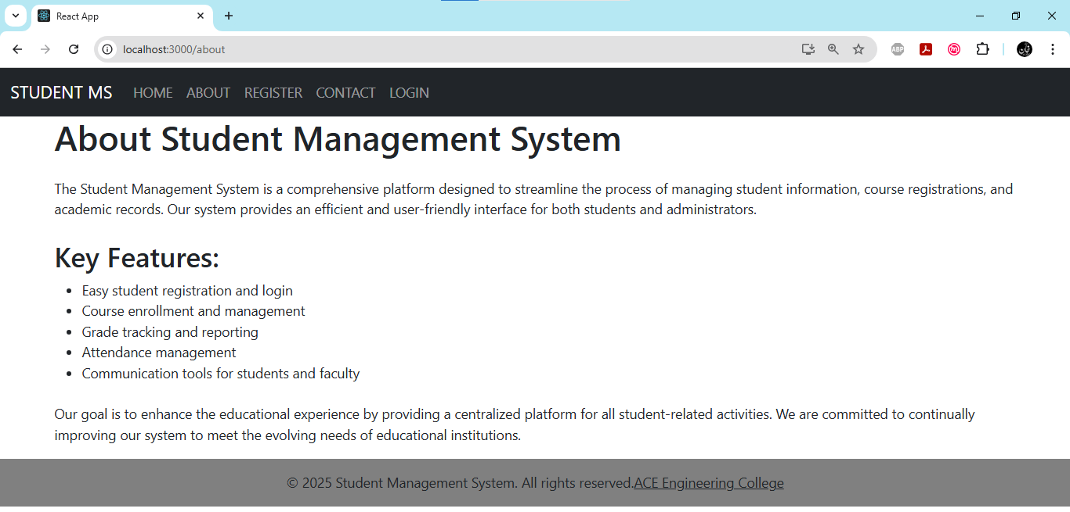
Register.js
import React from 'react';

const Register = () => {
return (
<div class="max-w-96" style={{width:"50%", marginLeft:"25rem"}}>
<h1 className="text-2xl font-bold mb-4">Student Registration</h1>
<form>

<div class="row mb-4">
<div class="col">
<div data-mdb-input-init class="form-outline">
<input type="text" id="form3Example1" class="form-control" />
<label class="form-label" for="form3Example1">First name</label>
</div>
</div>
<div class="col">
<div data-mdb-input-init class="form-outline">
<input type="text" id="form3Example2" class="form-control" />
<label class="form-label" for="form3Example2">Last name</label>
</div>
</div>
</div>

<div data-mdb-input-init class="form-outline mb-4">
<input type="email" id="form3Example3" class="form-control" />
<label class="form-label" for="form3Example3">Email</label>
</div>

<div data-mdb-input-init class="form-outline mb-4">
<input type="password" id="form3Example4" class="form-control" />
<label class="form-label" for="form3Example4">Password</label>
</div>

<div class="form-check d-flex justify-content-center mb-4">
<input class="form-check-input me-2" type="checkbox" value="" id="form2Example33" checked />
<label class="form-check-label" for="form2Example33">
Subscribe to our newsletter
</label>
</div>
<button data-mdb-ripple-init type="button" class="btn btn-primary btn-block mb-4" style={{width:"100%"}}>Sign up</button>
<div class="text-center">
</div>
</form>
</div>
);
};
export default Register;
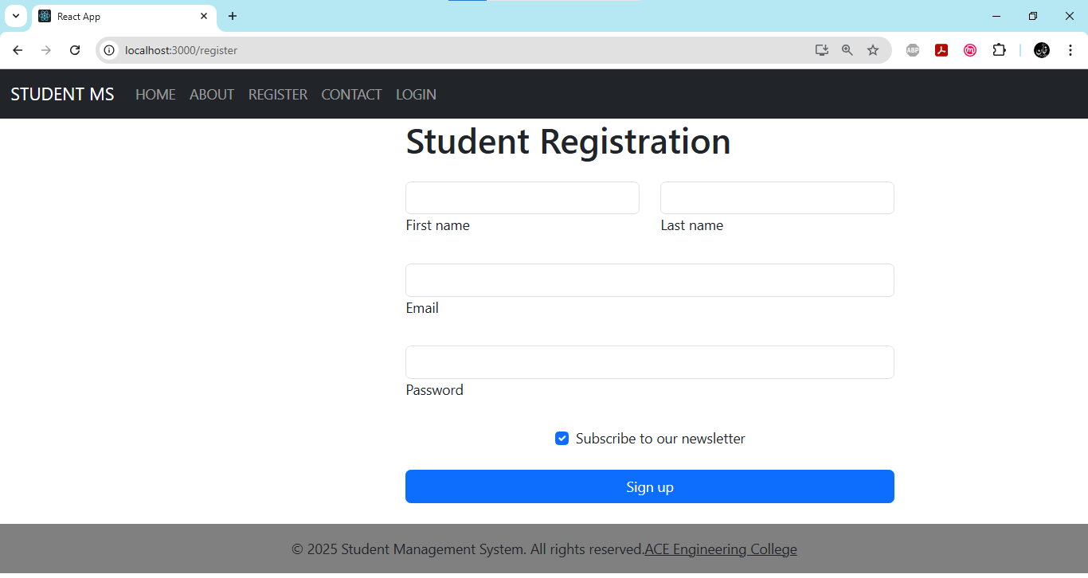
Login.js
import React from 'react';
const Login = () => {
return (
<div class="max-w-96" style={{width:"50%", marginLeft:"25rem"}}>
<h1 className="text-2xl font-bold mb-4">Student Login</h1>
<form>
<div data-mdb-input-init class="form-outline mb-4">
<input type="email" id="form2Example1" class="form-control" />
<label class="form-label" for="form2Example1">Email address</label>
</div>
<div data-mdb-input-init class="form-outline mb-4">
<input type="password" id="form2Example2" class="form-control" />
<label class="form-label" for="form2Example2">Password</label>
</div>
<div class="row mb-4">
<div class="col d-flex justify-content-center">
<div class="form-check">
<input class="form-check-input" type="checkbox" value="" id="form2Example34" checked />
<label class="form-check-label" for="form2Example34"> Remember me </label>
</div>
</div>
</div>
<button data-mdb-ripple-init type="button" class="btn btn-primary btn-block mb-4" style={{width:"100%"}}>Sign in</button>
<div class="text-center">
<p>Not a member? <a href="/register">Register</a></p>
</div>
</form>
</div>
);
};
export default Login;
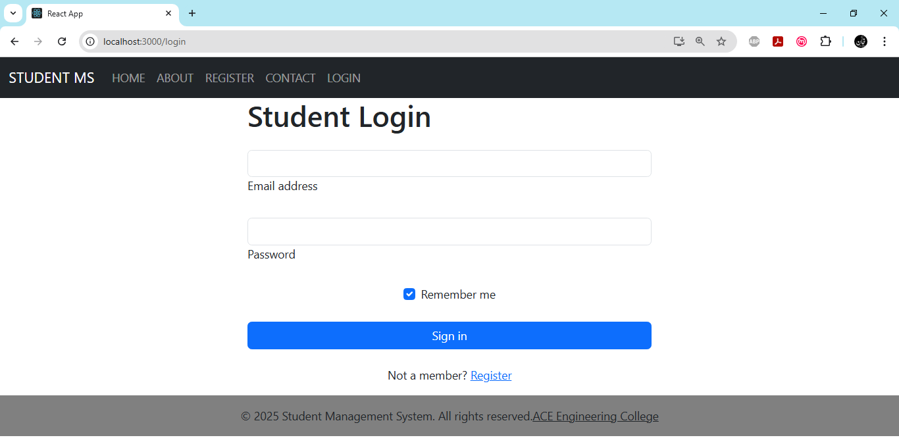
Contact.js
import React from 'react';
const Contact = () => {
return (
<div class="max-w-96" style={{width:"50%", marginLeft:"25rem"}}>
<h1 className="text-2xl font-bold mb-4">Contact Us</h1>
<form style={{width: "26rem"}}>
<div data-mdb-input-init class="form-outline mb-4">
<input type="text" id="form4Example1" class="form-control" />
<label class="form-label" for="form4Example1">Name</label>
</div>
<div data-mdb-input-init class="form-outline mb-4">
<input type="email" id="form4Example2" class="form-control" />
<label class="form-label" for="form4Example2">Email address</label>
</div>
<div data-mdb-input-init class="form-outline mb-4">
<textarea class="form-control" id="form4Example3" rows="4"></textarea>
<label class="form-label" for="form4Example3">Message</label>
</div>
<div class="form-check d-flex justify-content-center mb-4">
<input
class="form-check-input me-2"
type="checkbox"
value=""
id="form4Example4"
checked
/>
<label class="form-check-label" for="form4Example4">
Send me a copy of this message
</label>
</div>
<button data-mdb-ripple-init type="button" class="btn btn-primary btn-block mb-4" style={{width:"100%"}}>Send</button>
</form>
</div>
);
};
export default Contact;

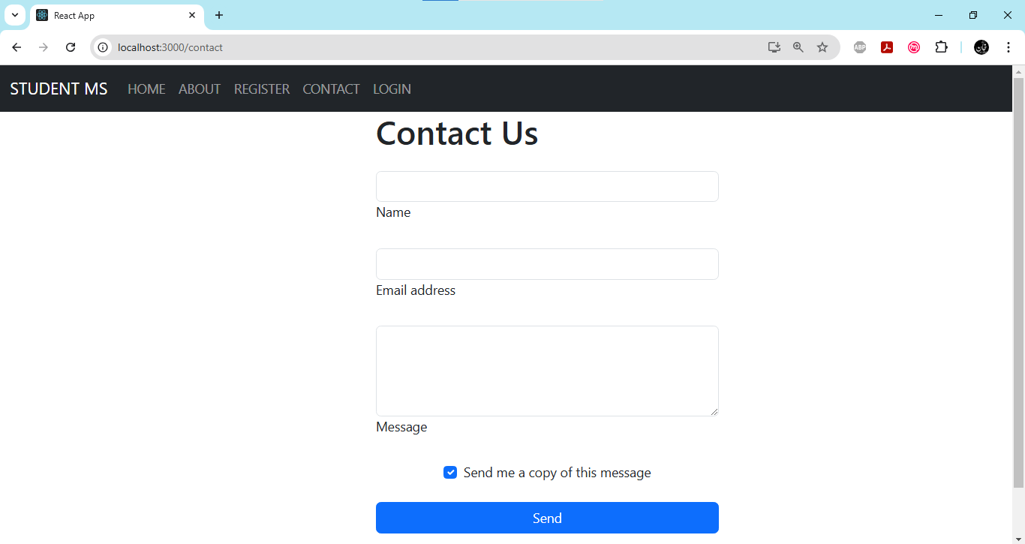
Step 5: Replace the content of the file src/App.js and src/Index.js
App.js
import React from 'react';
import { BrowserRouter as Router, Route, Routes } from 'react-router-dom';
import Layout from './components/Layout';
import Home from './pages/Home';
import Register from './pages/Register';
import Login from './pages/Login';
import Contact from './pages/Contact';
import About from './pages/About';
import "bootstrap/dist/css/bootstrap.min.css";
function App() {
return (
<Router>
<Layout>
<Routes>
<Route path="/" element={<Home />} />
<Route path="/register" element={<Register />} />
<Route path="/login" element={<Login />} />
<Route path="/contact" element={<Contact />} />
<Route path="/about" element={<About />} />
</Routes>
</Layout>
</Router>
);
}
export default App;

Index.js
import React from 'react';
import ReactDOM from 'react-dom/client';
import "bootstrap/dist/css/bootstrap.min.css";
import "bootstrap/dist/js/bootstrap.bundle.min.js";

import App from './App';
const root = ReactDOM.createRoot(document.getElementById('root'));
root.render(
<React.StrictMode>
<App />
</React.StrictMode>
);

Step 5: Run Your Application
Now that everything is set up, you can run your application:
npm start

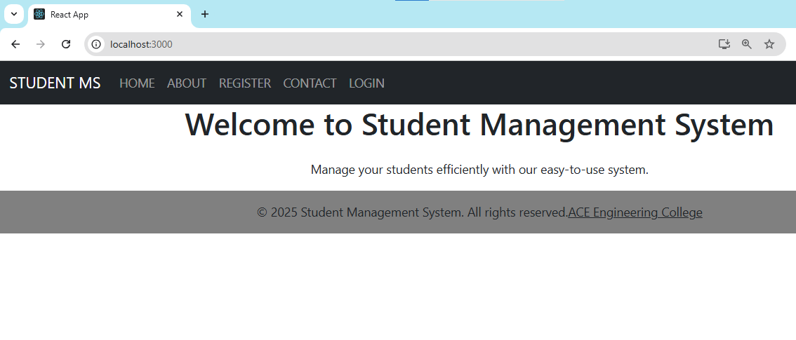

Experiment 13: Create a Service in React That Fetches Weather Information from OpenWeatherMap.org and Displays the Current and Historical Weather Information Using Graphical Representation Using Chart.js.
To create a React service that fetches weather information from OpenWeatherMap.org and displays both current and historical weather data using Chart.js, you can follow these steps. This guide assumes you have a basic understanding of React and JavaScript.

Step 1: Set Up Your React Application
1. Create a New React App:
Open your terminal and create a new React application.
npx create-react-app weather-app
cd weather-app
2. Install Required Packages:
You will need axios for making API calls and chart.js along with react-chartjs-2 for rendering charts.
npm install axios chart.js react-chartjs-2
npm install bootstrap
Step 2: Get Your OpenWeatherMap API Key
1. Sign Up: Go to [OpenWeatherMap](https://openweathermap.org/) and sign up for an account.
2. Get API Key: After signing up, go to the API section and get your API key.

Step 3: Create a Weather Service
Create a new folder named services in the src directory and create a file named WeatherService.js.
mkdir src/services
touch src/services/WeatherService.js
WeatherService.js
import axios from "axios";
const API_KEY = "f6dc4f4e7b873301bc6afaeb13e4ea58";
const WEATHER_URL = "https://api.openweathermap.org/data/3.0/onecall";
const GEO_URL = "https://api.openweathermap.org/geo/1.0/direct";

const WeatherService = {
// Get coordinates from city name
getCityCoordinates: async (city) => {
try {
const response = await axios.get(GEO_URL, {
params: { q: city, limit: 1, appid: API_KEY },
});
if (response.data.length === 0) throw new Error("City not found");
return response.data[0]; // Returns { lat, lon, name }
} catch (error) {
console.error("Error fetching city coordinates:", error);
return null;
}
},
// Get weather using lat/lon
getWeather: async (lat, lon) => {
try {
const response = await axios.get(WEATHER_URL, {
params: {
lat,
lon,
exclude: "minutely,hourly,alerts",
units: "metric",
appid: API_KEY,
},
});
return response.data;
} catch (error) {
console.error("Error fetching weather data:", error);
return null;
}
},
};
export default WeatherService;

Step 4: Create Components
1. Create a folder named components:
mkdir src/components
2. Create a WeatherChart Component:
Create a file named WeatherChart.js in the components folder.
// src/components/WeatherChart.js
import React from "react";
import { Line } from "react-chartjs-2";
import { Chart as ChartJS, CategoryScale, LinearScale, PointElement, LineElement, Title, Tooltip, Legend } from "chart.js";
ChartJS.register(CategoryScale, LinearScale, PointElement, LineElement, Title, Tooltip, Legend);
const WeatherChart = ({ data, city }) => {
if (!data) return <p>Loading chart...</p>;
// Extract temperatures & dates
const labels = data.map((d) => new Date(d.dt * 1000).toLocaleDateString());
const temperatures = data.map((d) => d.temp.day);
const chartData = {
labels,
datasets: [
{
label: `Temperature in ${city} (°C)`,
data: temperatures,
borderColor: "red",
backgroundColor: "rgba(255, 0, 0, 0.3)",
},
],
};
return <Line data={chartData} />;
};
export default WeatherChart;

Step 5: Update the App Component
Now, update your App.js
import React, { useState } from "react";
import axios from "axios";
import { Line } from "react-chartjs-2";
import { Chart as ChartJS, CategoryScale, LinearScale, PointElement, LineElement, Title, Tooltip, Legend } from "chart.js";
ChartJS.register(CategoryScale, LinearScale, PointElement, LineElement, Title, Tooltip, Legend);
const API_KEY = "f6dc4f4e7b873301bc6afaeb13e4ea58"; // Replace with your key
const WEATHER_URL = "https://api.openweathermap.org/data/2.5/weather";
const FORECAST_URL = "https://api.openweathermap.org/data/2.5/forecast";
const App = () => {
const [city, setCity] = useState("Hyderabad");
const [weatherData, setWeatherData] = useState(null);
const fetchWeather = async (cityName) => {
try {
console.log("Fetching weather for:", cityName);
// Fetch current weather
const currentWeatherResponse = await axios.get(WEATHER_URL, {
params: { q: cityName, units: "metric", appid: API_KEY },
});
console.log("Current Weather Data:", currentWeatherResponse.data);
// Fetch 5-day forecast
const forecastResponse = await axios.get(FORECAST_URL, {
params: { q: cityName, units: "metric", appid: API_KEY },
});
console.log("Forecast Data:", forecastResponse.data);
// Extract relevant data for the next 5 days
const forecastData = forecastResponse.data.list.filter((entry, index) => index % 8 === 0).slice(0, 5);
setWeatherData({
currentTemp: currentWeatherResponse.data.main.temp,
forecast: forecastData,
});
} catch (error) {
console.error("Error fetching weather:", error);
alert("Could not fetch weather data. Please check the city name or try again later.");
}
};
const handleSearch = () => {
if (!city.trim()) {
alert("Please enter a city name.");
return;
}
fetchWeather(city);
};
return (
<div style={{ textAlign: "center", padding: "20px" }}>
<h2>Weather Forecast</h2>
<input
type="text"
value={city}
onChange={(e) => setCity(e.target.value)}
placeholder="Enter city name"
/>
<button onClick={handleSearch}>Get Weather</button>
{weatherData ? (
<div>
<h3>Current Temperature in {city}: {weatherData.currentTemp}°C</h3>
<div style={{ width: "400px", height: "250px", margin: "auto" }}>
<Line
data={{
labels: weatherData.forecast.map((d) => new Date(d.dt * 1000).toLocaleDateString()),
datasets: [
{
label: `Temperature Forecast (°C)`,
data: weatherData.forecast.map((d) => d.main.temp),
borderColor: "blue",
backgroundColor: "rgba(0, 0, 255, 0.3)",
},
],
}}
options={{
maintainAspectRatio: false, // Ensures it respects div size
}}
/>
</div>
</div>
) : (
<p>Enter a city and click "Get Weather"</p>
)}
</div>
);
};
export default App;

Step 6: Run Your Application
Run your application locally to test it.
npm start

Step 7: Access Your Application
Open your browser and go to http://localhost:3000 .

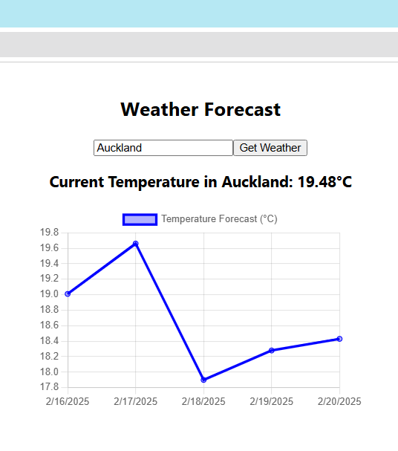
Experiment 14: Create a TODO application in react with necessary components and deploy it into github.
Creating a TODO application in React involves several steps, including setting up the project, creating components, managing state, and deploying it to GitHub. Following is the step-by-step process.
Step 1: Set Up Your React Application
1. Create a New React App:
Open your terminal and create a new React application using Create React App.
npx create-react-app todo-app
cd todo-app
2. Install Additional Packages (Optional):
If you plan to use any additional libraries (like Bootstrap for styling), you can install them. For example, to install Bootstrap:
npm install bootstrap
Step 2: Create the Necessary Components
For a simple TODO application, we will create the following components:
- TodoList.js: To display the list of todos.
- TodoItem.js: To display individual todo items.
- AddTodo.js: To add new todos.

1. Create a components Directory
Inside the src directory, create a folder named components.
mkdir src/components
2. Create the TodoItem Component
Create a file named TodoItem.js inside the components folder.
// src/components/TodoItem.js
import React from 'react';
const TodoItem = ({ todo, onDelete }) => {
return (
<div className="todo-item">
<span>{todo.text}</span>
<input type=”submit” value=”Delete” onClick={() => onDelete(todo.id)}/>
</div>
);
};
export default TodoItem;
3. Create the TodoList Component
// src/components/TodoList.js
import React from 'react';
import TodoItem from './TodoItem';
const TodoList = ({ todos, onDelete }) => {
return (
<div className="todo-list">
{todos.map(todo => (
<TodoItem key={todo.id} todo={todo} onDelete={onDelete} />
))}
</div>
);
};
export default TodoList;
4. Create the AddTodo Component
Create a file named AddTodo.js.
// src/components/AddTodo.js
import React, { useState } from 'react';
const AddTodo = ({ onAdd }) => {
const [inputValue, setInputValue] = useState('');
const handleSubmit = (e) => {
e.preventDefault();
if (inputValue.trim() === '') return;
onAdd(inputValue);
setInputValue('');
};
return (
<form onSubmit={handleSubmit}>
<input
type="text"
value={inputValue}
onChange={(e) => setInputValue(e.target.value)}
placeholder="Add a new todo"
/>
<input type="submit" value=”Add”/>
</form>
);
};
export default AddTodo;
Step 3: Create the Main Application Component (src/App.js)
Now, modify the App.js file to use these components and manage the state.
// src/App.js
import React, { useState } from 'react';
import TodoList from './components/TodoList';
import AddTodo from './components/AddTodo';
import 'bootstrap/dist/css/bootstrap.min.css';
function App() {
const [todos, setTodos] = useState([]);
const addTodo = (text) => {
const newTodo = { id: Date.now(), text };
setTodos([...todos, newTodo]);
};

const deleteTodo = (id) => {
setTodos(todos.filter(todo => todo.id !== id));
};
return (
<div className="container mt-5">
<h1 className="text-center">TODO App</h1>
<AddTodo onAdd={addTodo} />
<TodoList todos={todos} onDelete={deleteTodo} />
</div>
);
}
export default App;
Step 4: Create CSS file (App.css - Optional) and import in App.js
.container {
max-width: 600px;
margin: auto;
}
.button[type=text]{background-color: #008CBA;} /* Blue */
.todo-item {
display: flex;
justify-content: space-between;
align-items: center;
padding: 10px;
border: 1px solid #ccc;
margin: 5px 0;
}
input[type=text], select {
flex:1;
width: 100%;
padding: 12px 20px;
margin: 8px 0;
display: inline-block;
border: 1px solid #ccc;
border-radius: 4px;
box-sizing: border-box;
}
input[type=submit] {
width: 30%;
background-color: #4CAF50;
color: white;
padding: 14px 20px;
margin: 8px 0;
border: none;
border-radius: 4px;
cursor: pointer;
}
input[type=submit]:hover {
background-color: #45a049;
}
Step 5: Run Your Application
Run your application locally to test it.
npm start
Step 6: Deploy to GitHub
1. Initialize a Git Repository:
In your terminal, make sure you are in the root of your project directory and initialize a Git repository.
git init
2. Create a .gitignore File:
Create a .gitignore file to exclude unnecessary files from being tracked.
echo "node_modules/" >> .gitignore
echo "build/" >> .gitignore
3. Add and Commit Your Changes:
git add .
git commit -m "Initial commit of TODO application"
4. Create a New Repository on GitHub:
Go to GitHub, create a new repository, and copy the repository URL.

5. Link Your Local Repository to GitHub:
In your terminal, link your local repository to the GitHub repository.
git remote add origin https://github.com/yourusername/todo-app.git
6. Push Your Code to GitHub:
git push -u origin master
Step 7: Deploy Your Application
You can deploy your React application using GitHub Pages. Here’s how:
1. Install gh-pages:
Install the gh-pages package.
npm install gh-pages --save-dev
2. Update package.json:
Add the following properties to your package.json:
json
"homepage": "https://yourusername.github.io/todo-app",
And add the following scripts:
"scripts": {
"predeploy": "npm run build",
"deploy": "gh-pages -d build"
}
3. Deploy Your Application:
Run the deploy command.
npm run deploy
Step 8: Access Your Deployed Application
After deploying, you can access your TODO application at the URL you specified in the homepage property of package.json. It should look like this:
https://yourusername.github.io/todo-app
